**PROBLEM SOLVING USING COMPUTERS**

**Lab 1. Sequential Instruction Based C Programs**

1. Program to print “Hello” on the Screen.

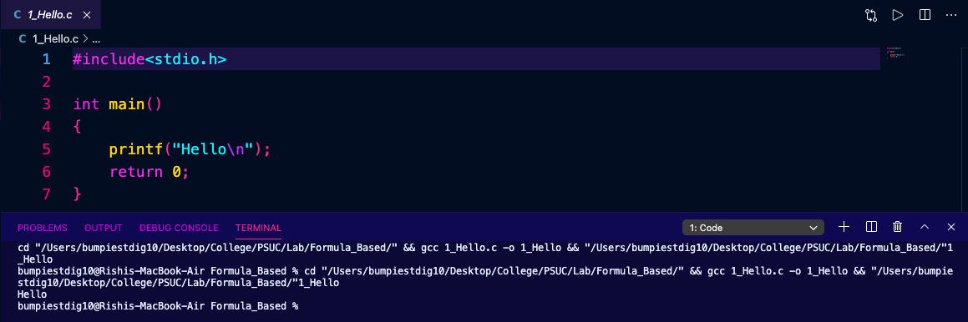

1. Write a program to take an input of two integer numbers and print the sum of that numbers.

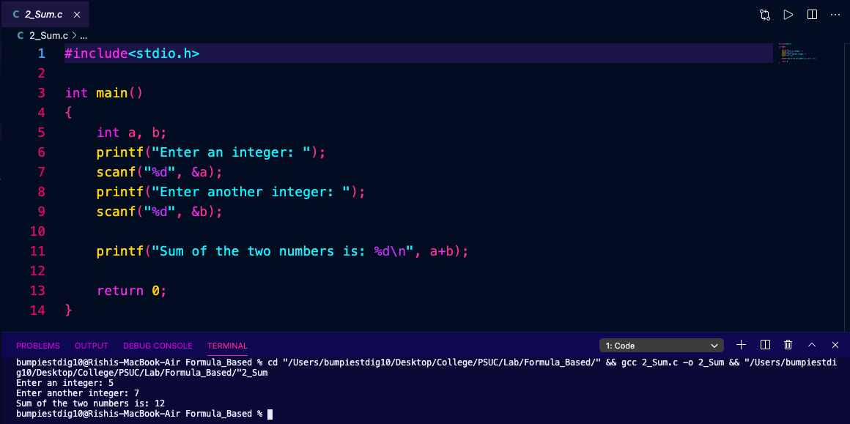

1. Convert the time in seconds to hours, minutes and seconds. (1 hr =3600 sec).

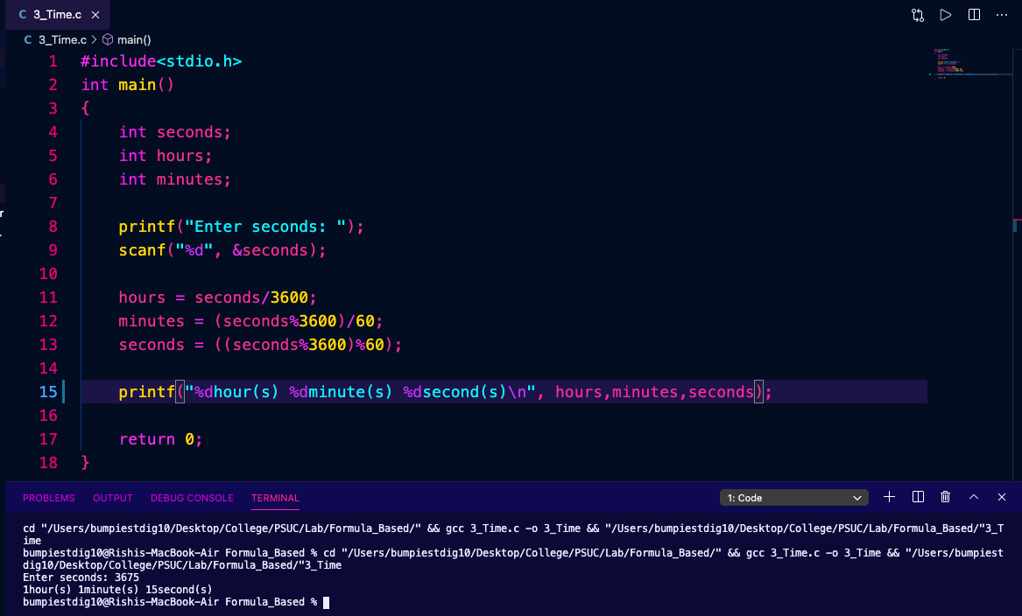

1. Find the sum of the digits of a four-digit number (ex 1234 sum=10) (without using a loop).

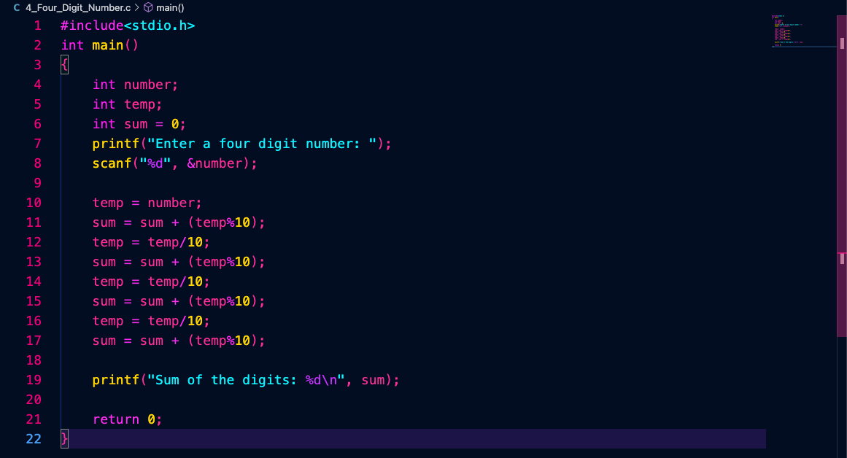

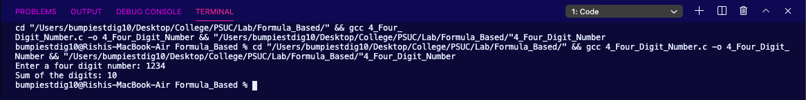

1. Convert temperature given in Fahrenheit to Centigrade and Centigrade to Fahrenheit. Hint: C=5/9(F-32)).

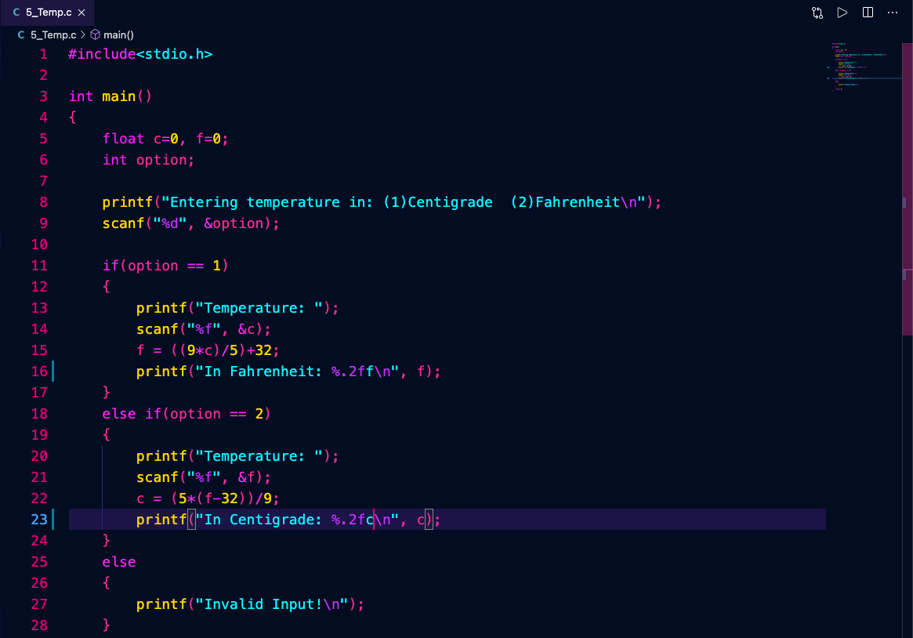

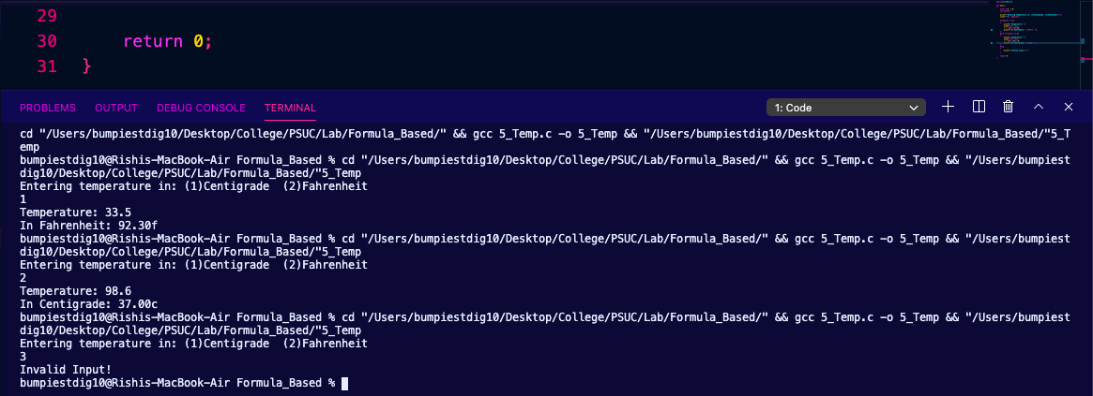

1. Converting distance in mm to cm, inch, feet (1 cm =10mm, 1inch=2.5cm, 1 feet =12 inches).

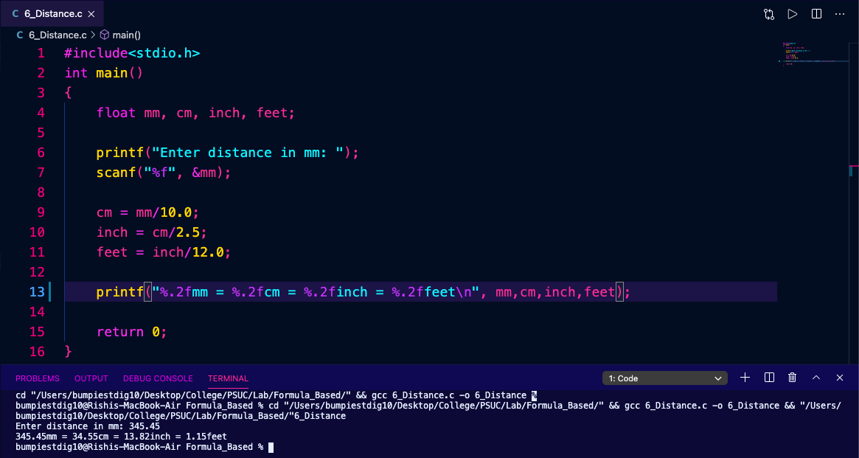

1. Find out the distance between two points e.g. (x1, y1) and (x2, y2).

Hint: Distance=√(x2-x1)2+ (y2-y1)2

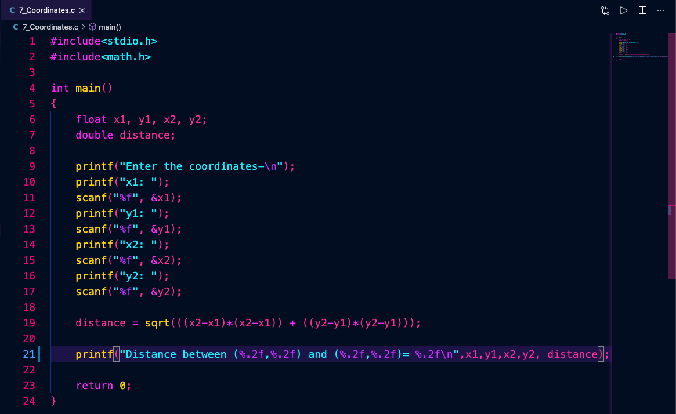

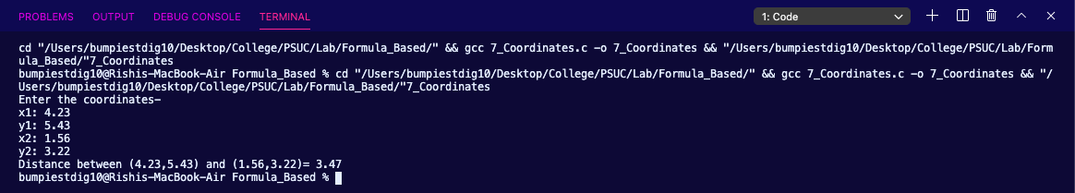

1. Evaluate the area of the circle Area = Pi * R2

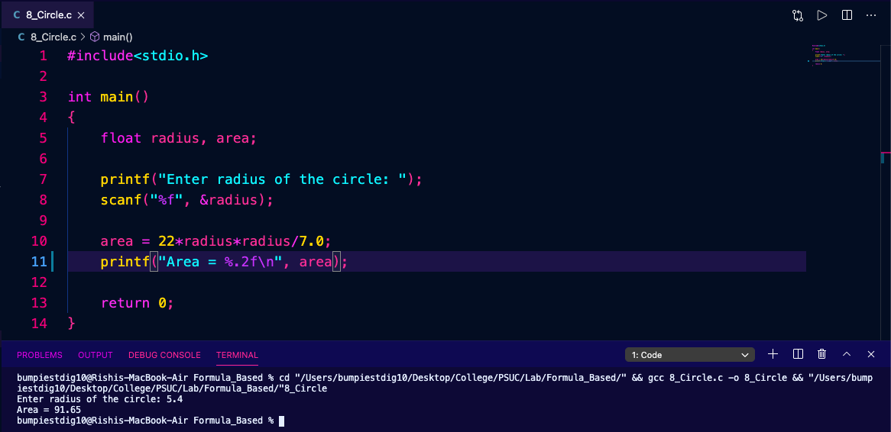

1. Interchange values of two variables using a third variable.

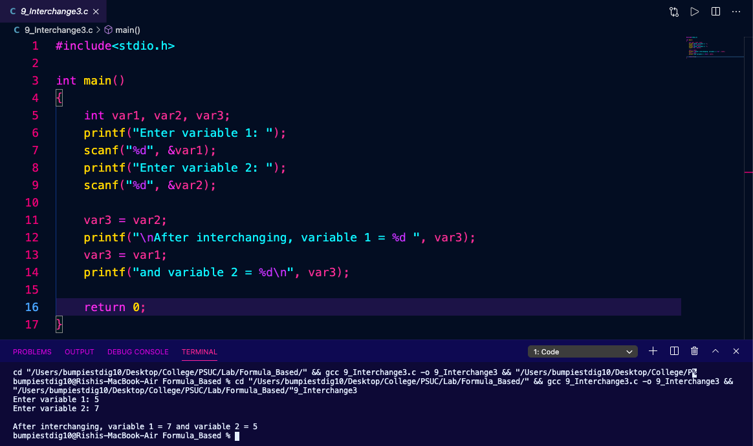

1. Interchange values of two variables without using a third variable.

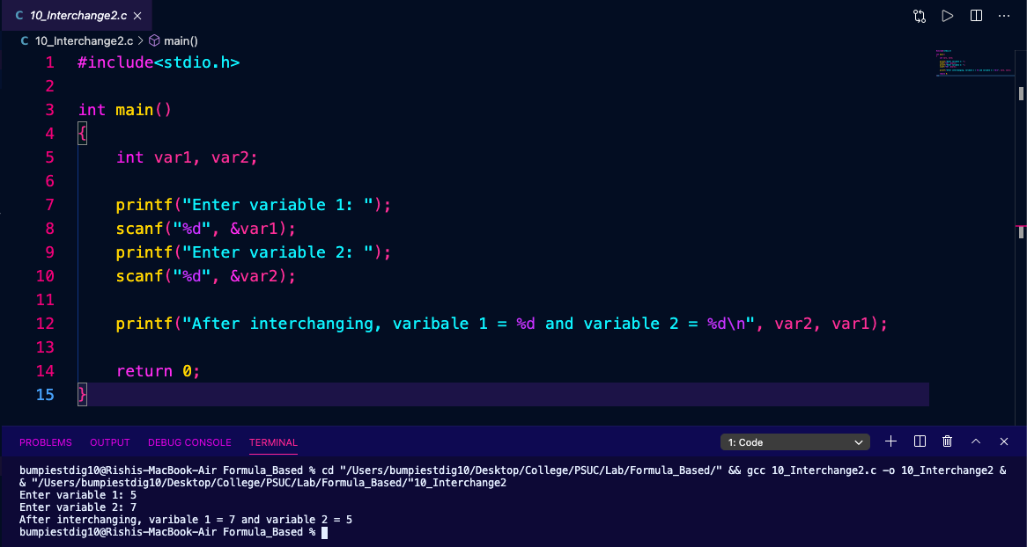

**Lab 2. Control Structures: If, If-Else and Switch-Case statements**

1. Check whether the given number is odd or even.

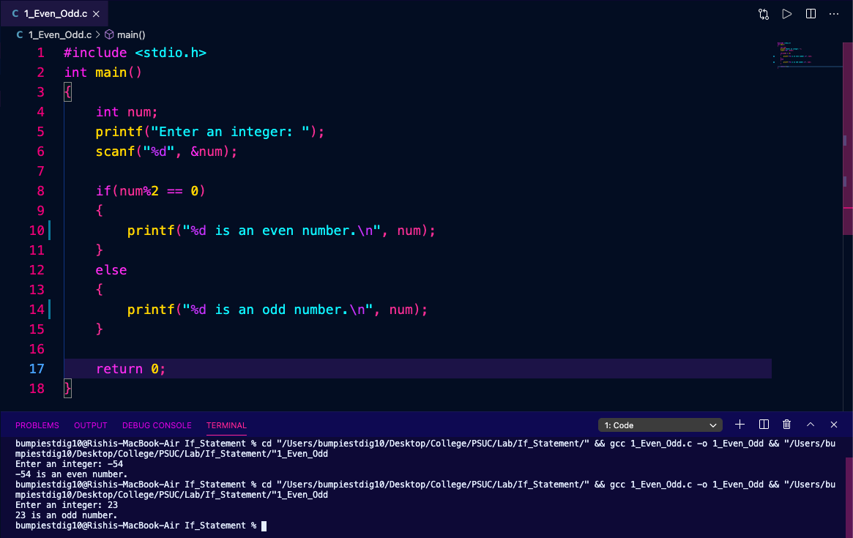

1. Check whether a given year is a leap year or not.

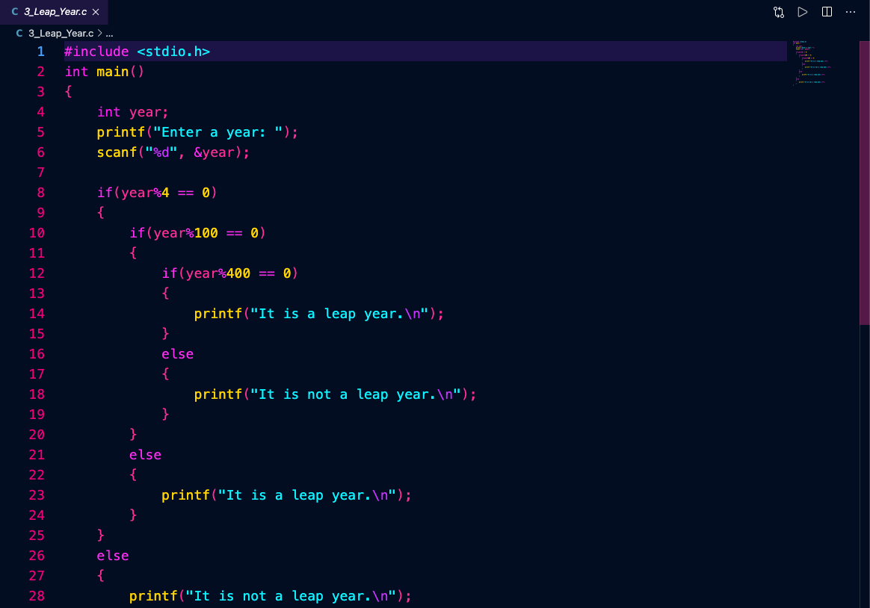

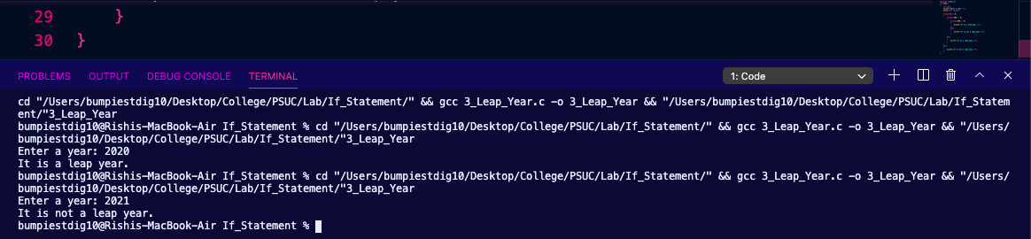

1. Write a program to take two numbers as an input and find whether one number is multiple of other or not.

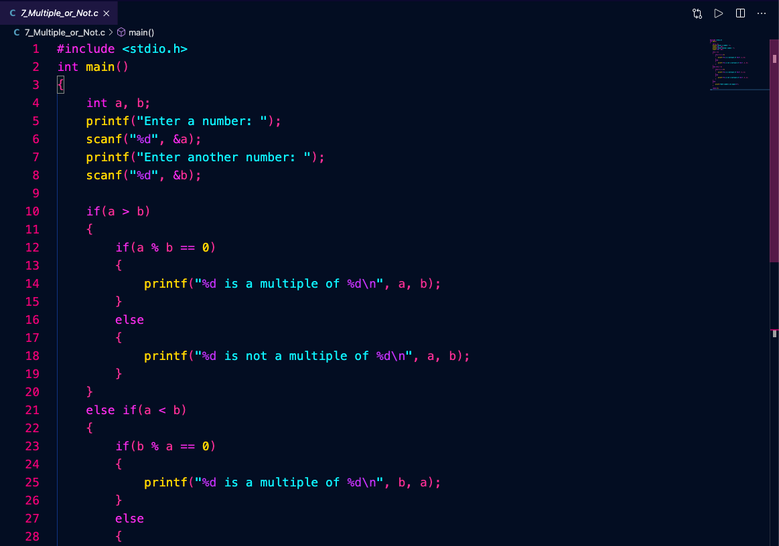

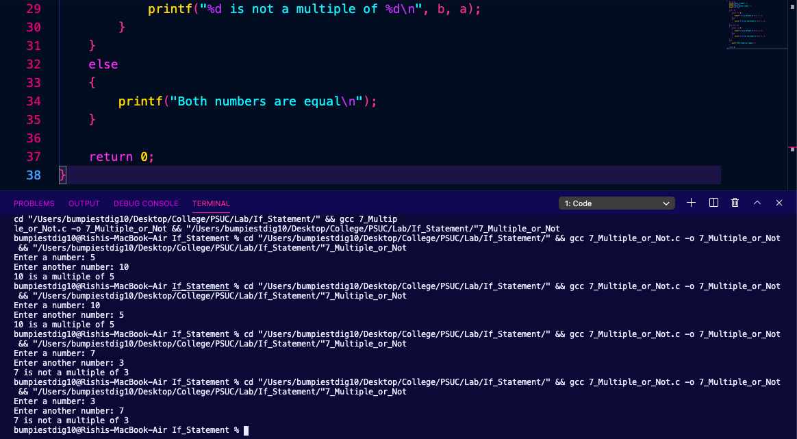

1. Write a program that returns a letter grade based on a quiz score. The input will be the integer score from a ten-point quiz.
   1. The letter grades are assigned by:
   2. 9 – 10 “A” 7 – 8 “B” 5 – 6 “C” 3 – 4 “D” < 3 “F”

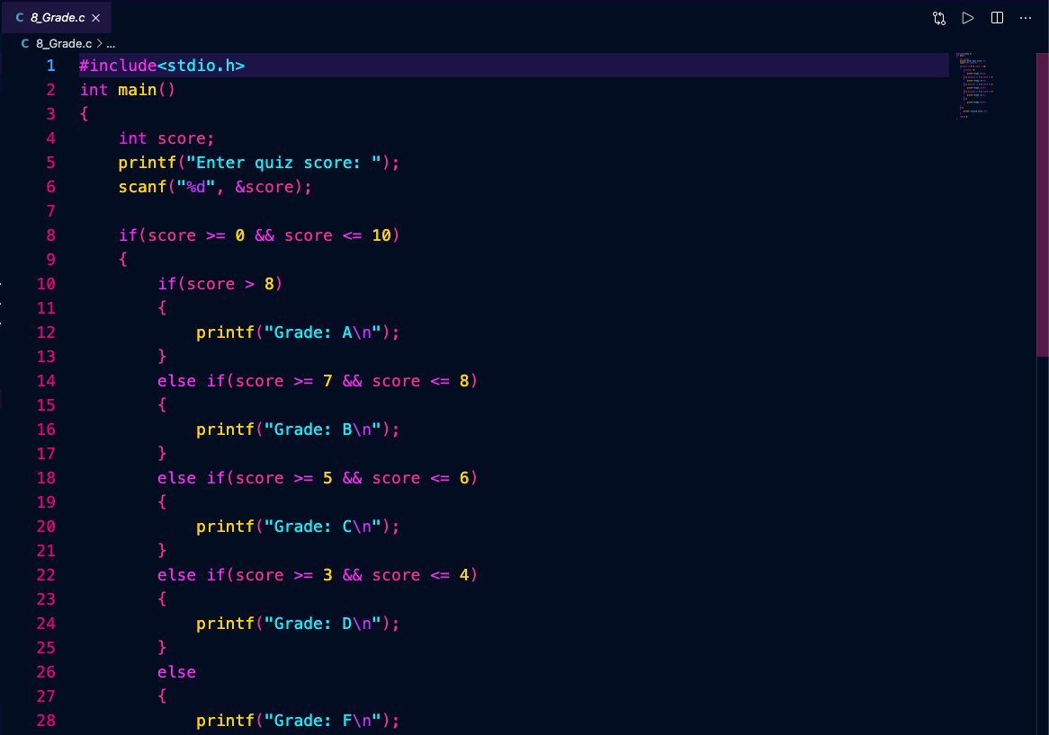

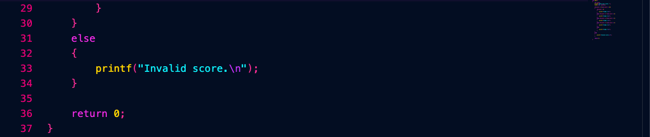

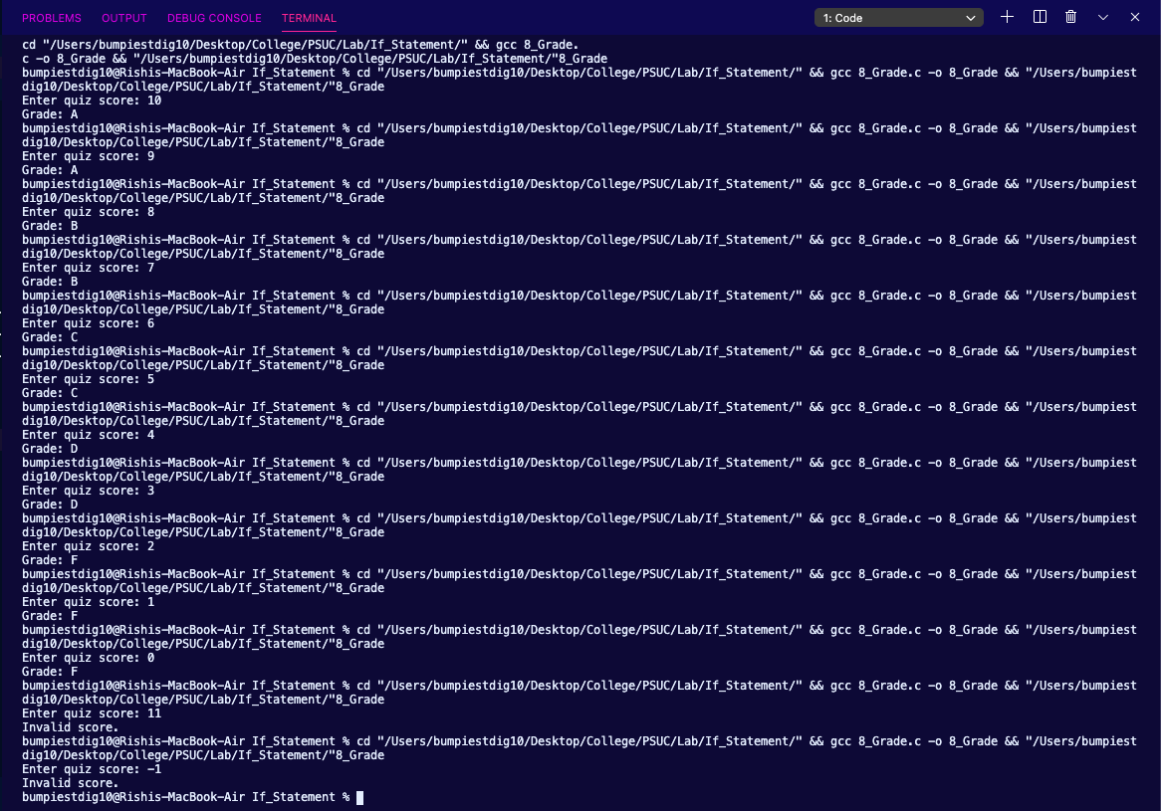

1. Write a program to check whether given character is vowel, consonant or digit.

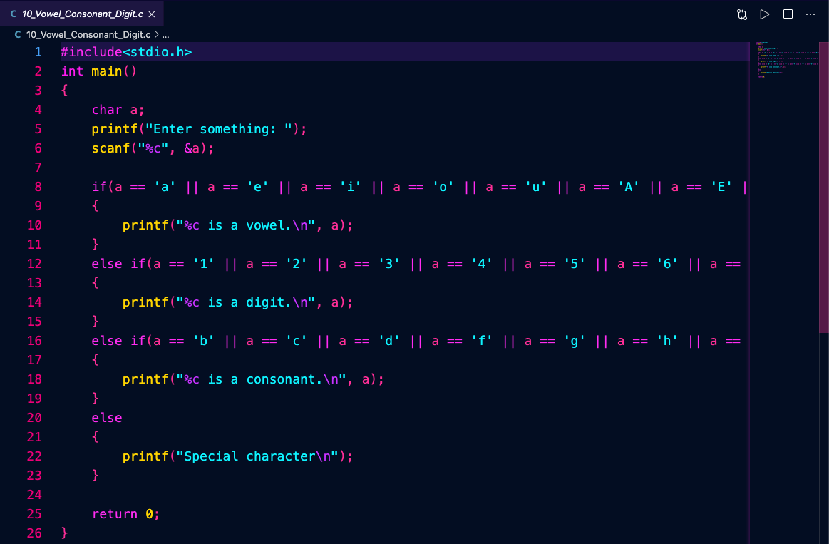

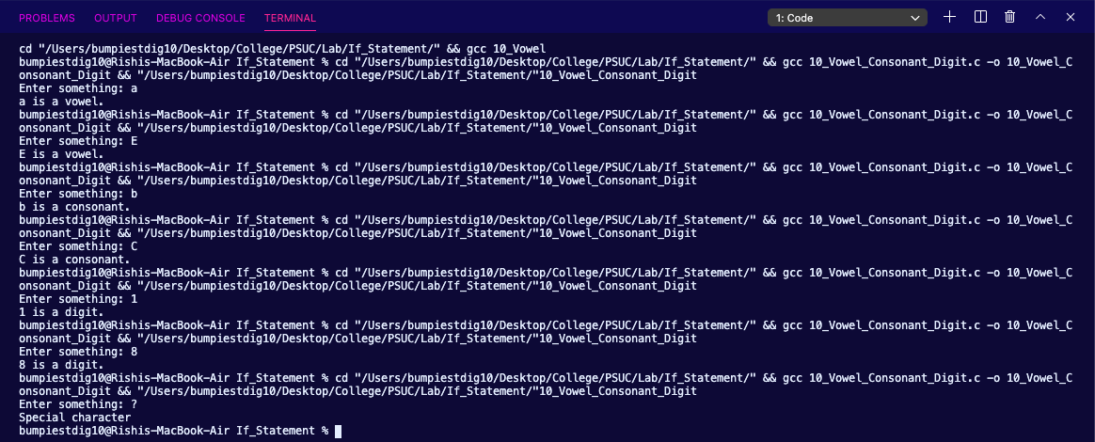

**Control Structures: Switch-Case**

1. Program to calculate an area of a circle, a rectangle or a triangle depending on user’s choice.

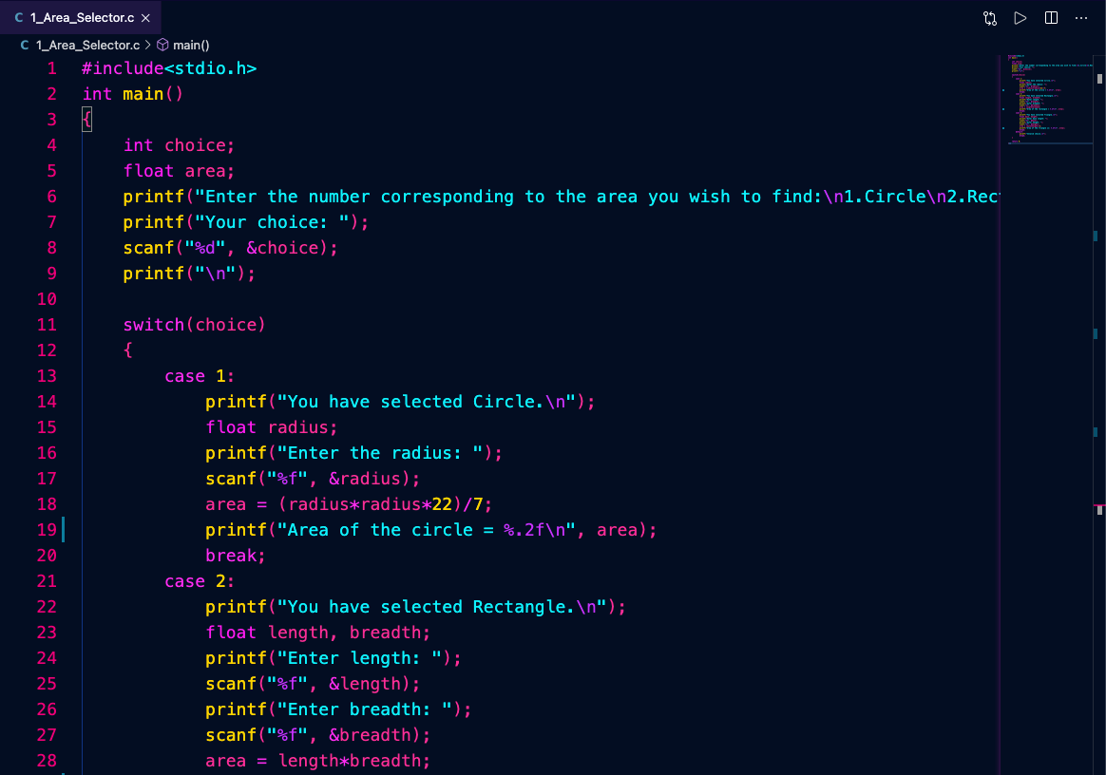

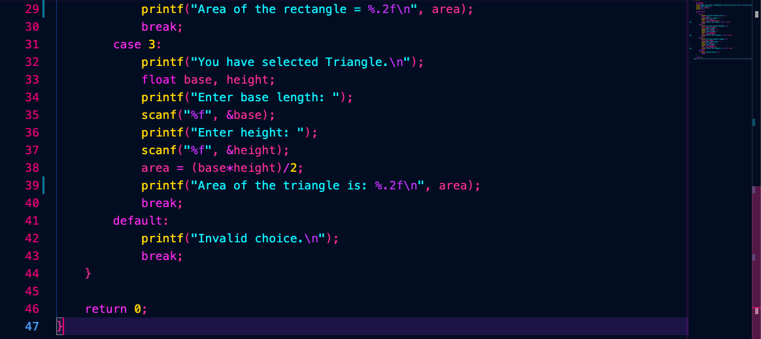

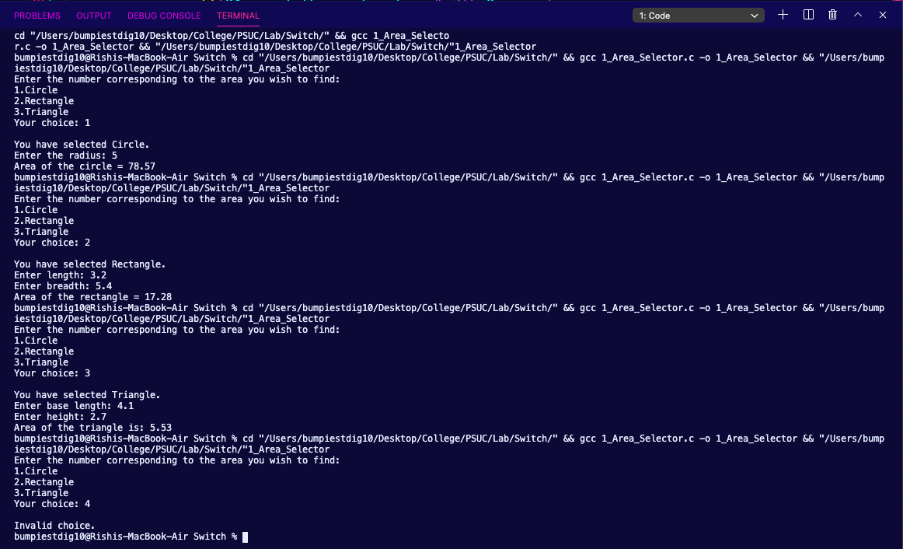

1. Write a program to design a calculator that performs addition, subtraction, minus and division operation. This program inputs two operands and an operator and then displays the calculated results.

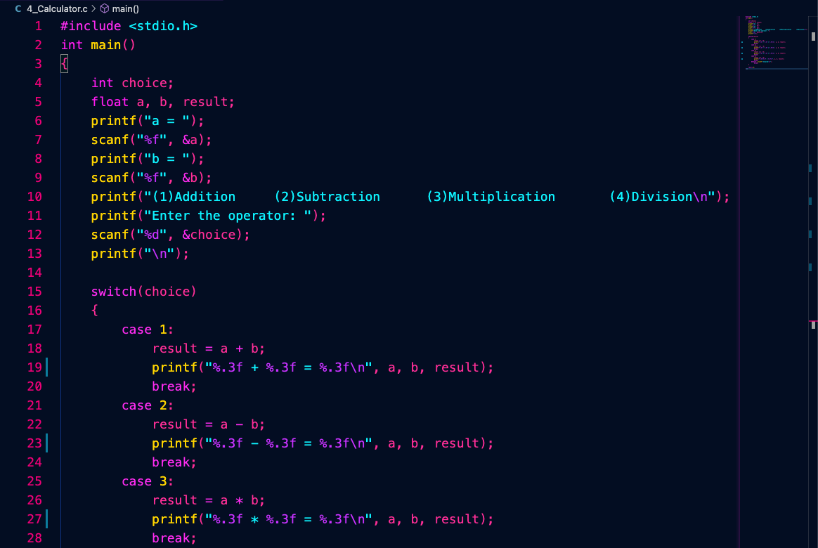

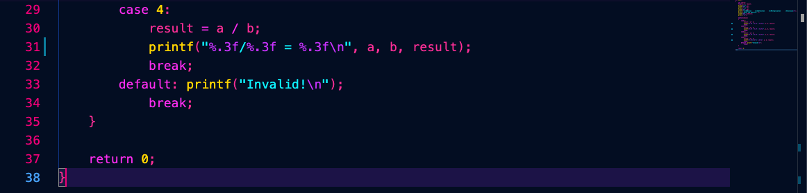

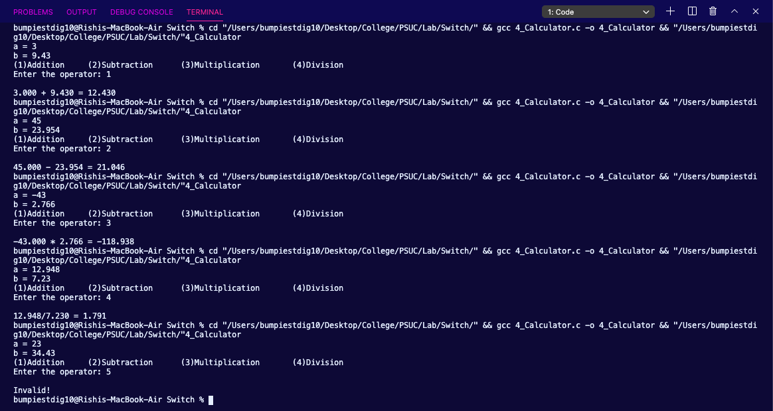

1. Write a program to calculate a bill of internet browsing. The conditions are given below:

Minimum Rs. 200 for up to 100 calls

Plus, Rs. 0.60 per call for next 50 calls.

Plus, Rs. 0.50 per call for next 50 calls.

Plus, Rs. 0.40 per call for any call beyond 200 calls

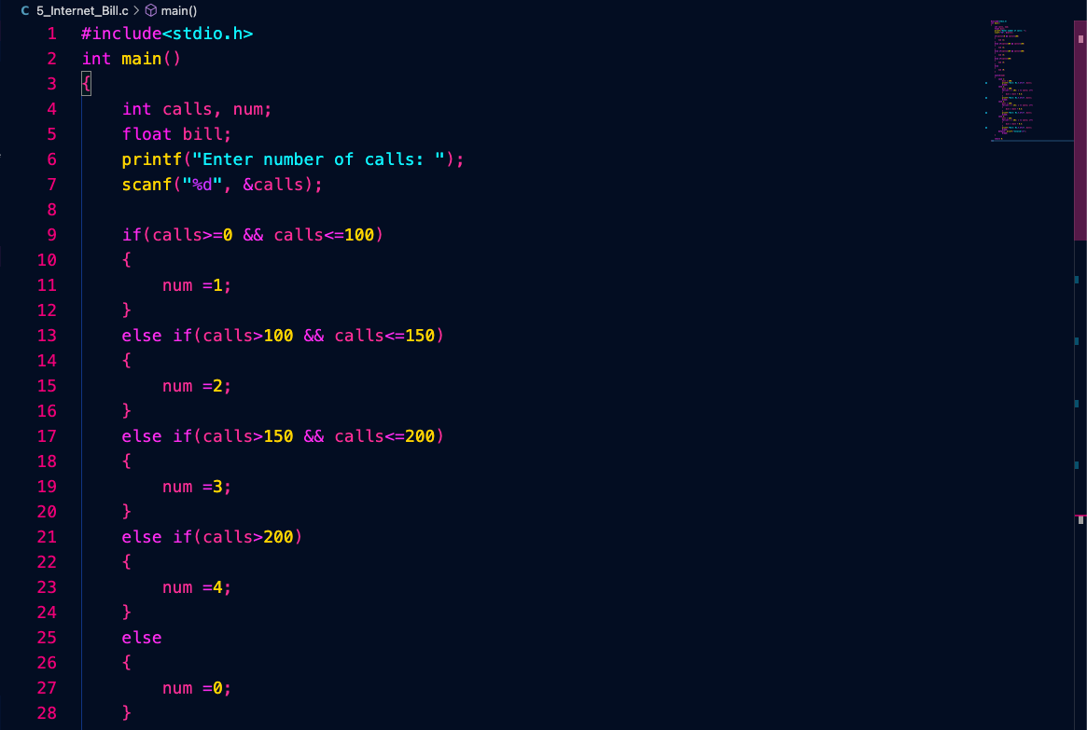

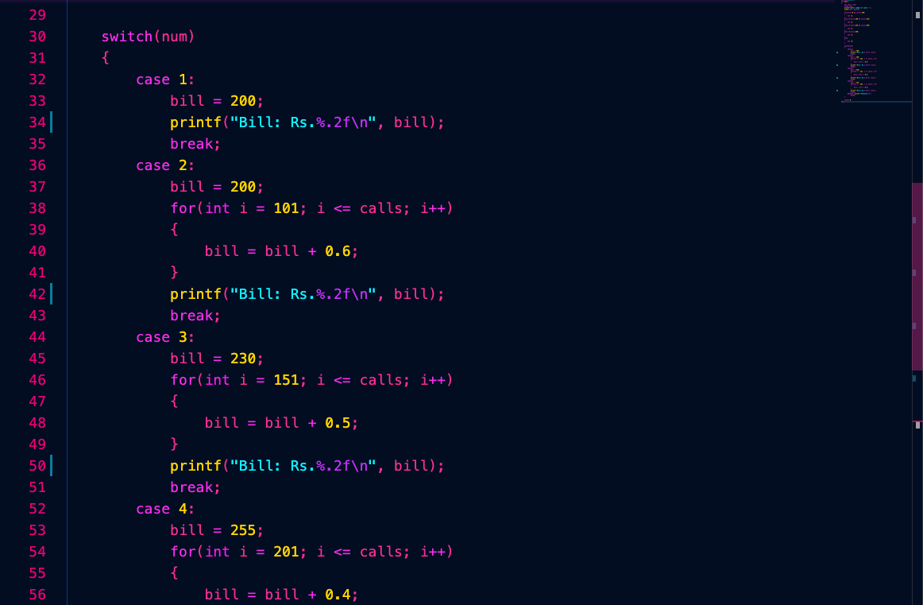

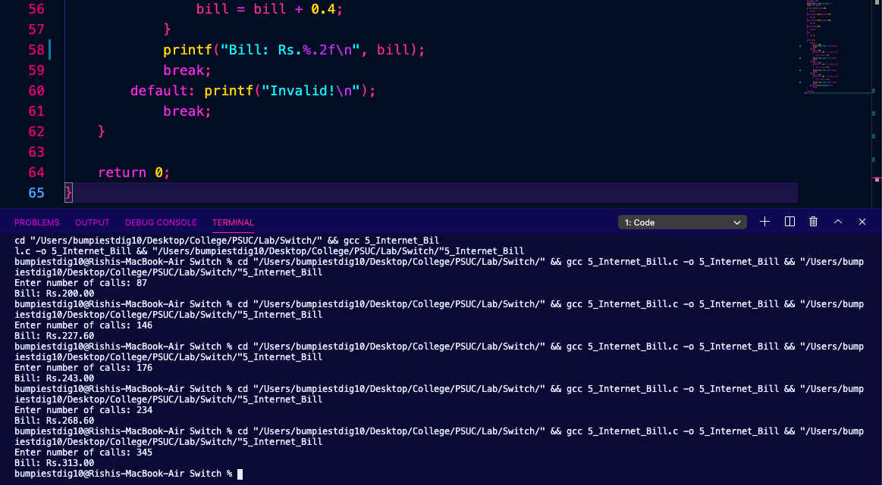

**Lab 3. Control Structures: Loops and Nested Loops**

1. Write a program to print the sum of N natural numbers.

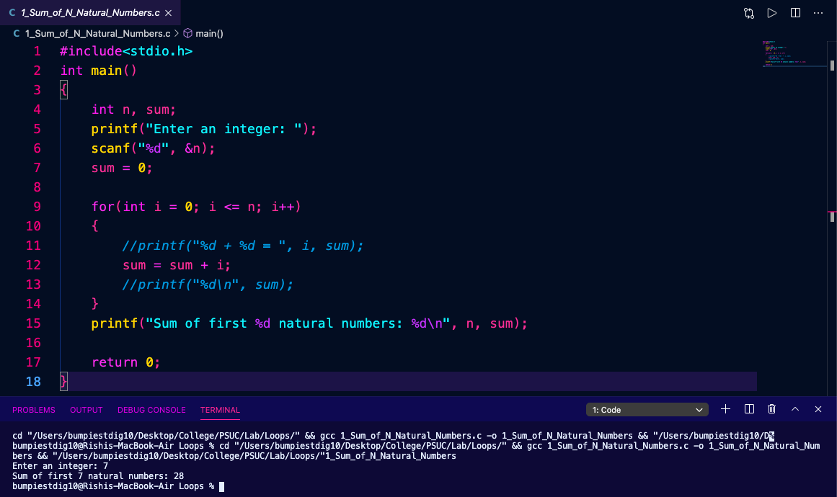

1. Write a program to take N as input print the odd numbers in descending order.

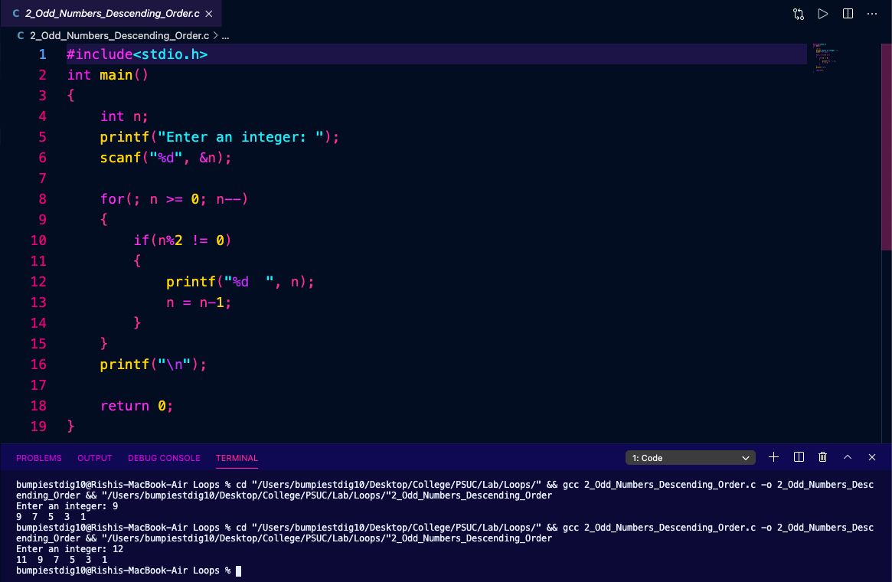

1. Write a program to print the Nth Fibonacci number.

Hint: (Fibonacci series is 0, 1, 1, 2, 3, 5, 8)

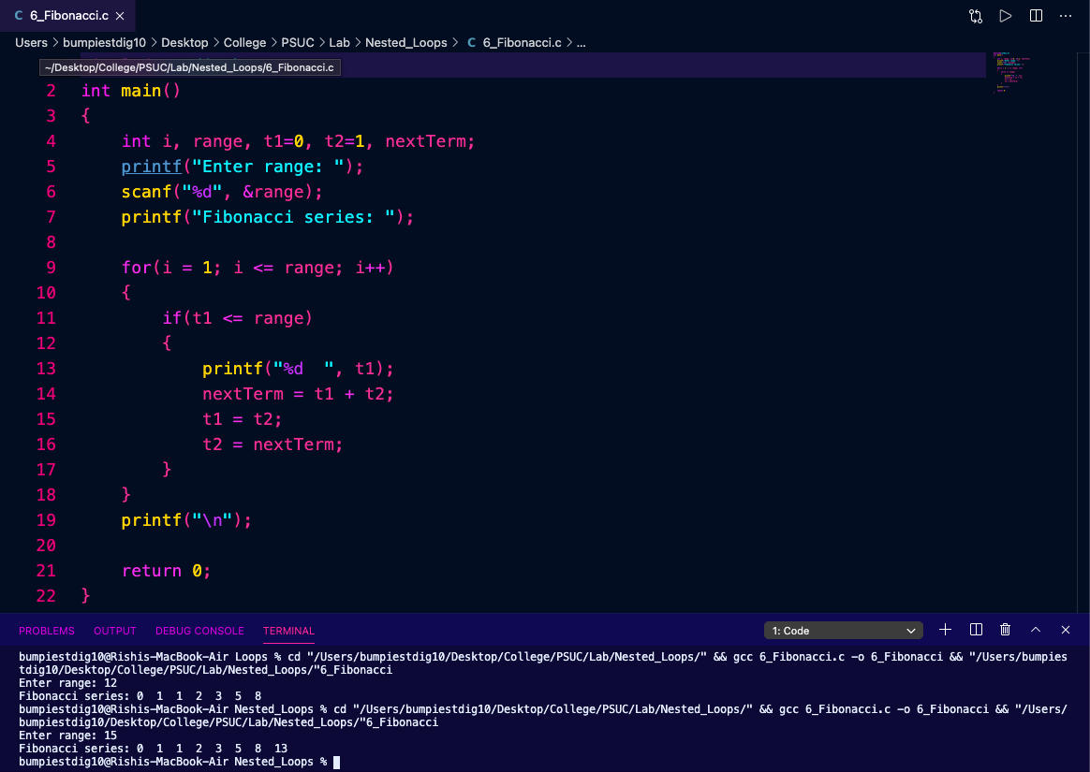

1. Find whether given number is prime or not.

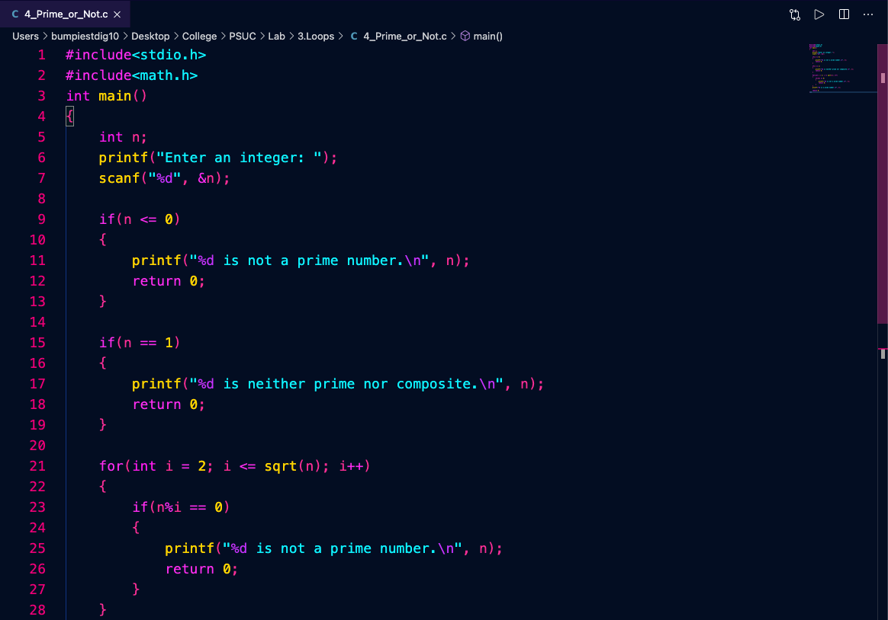

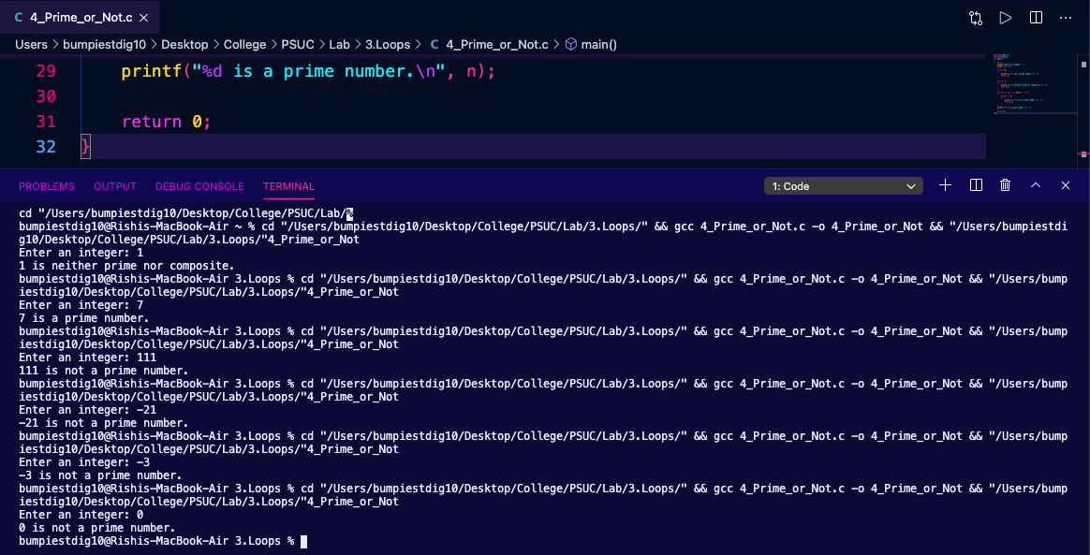

1. Convert the decimal number into binary to decimal.

Ex: 1101 = 1*23 + 1 * 22 + 0 * 21+ 1* 20 =13

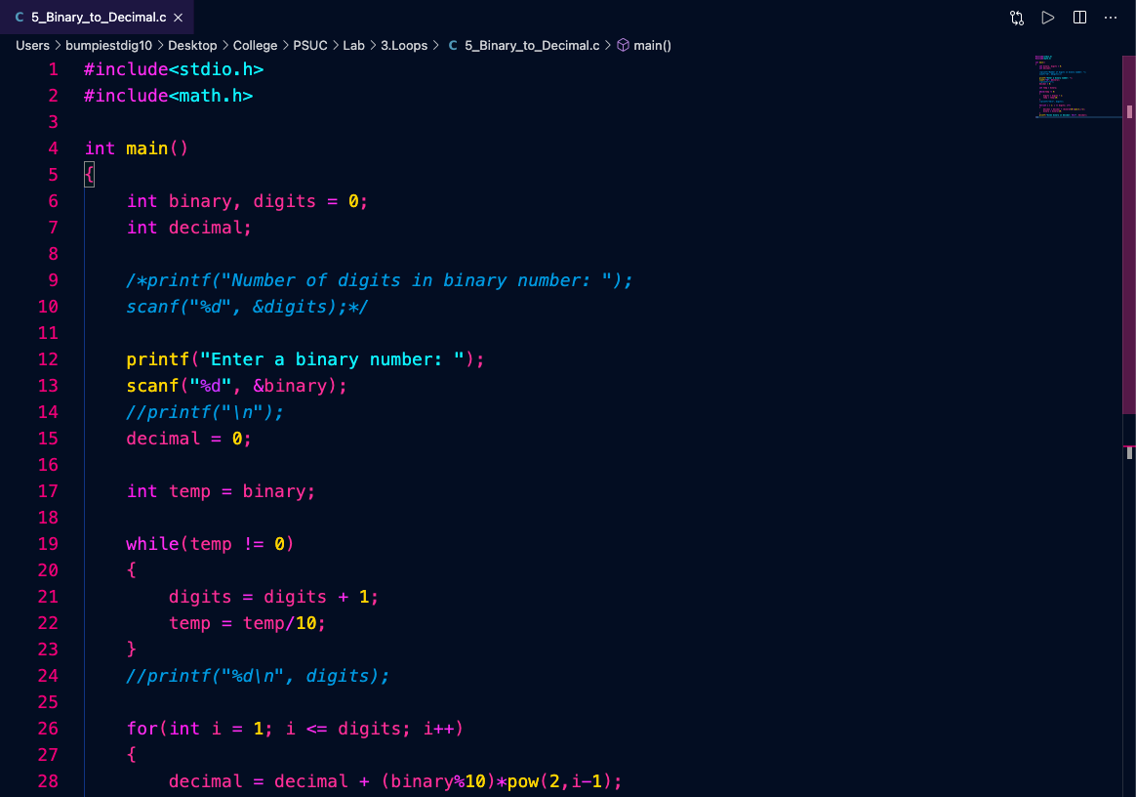

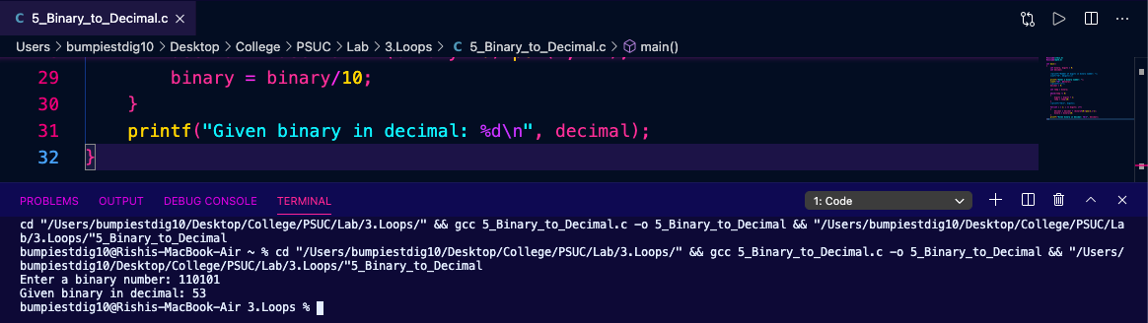

1. Reverse a given number

Ex: 1234 reverse=4*103 +3 * 102 + 2 * 101 + 1 * 100 =4321

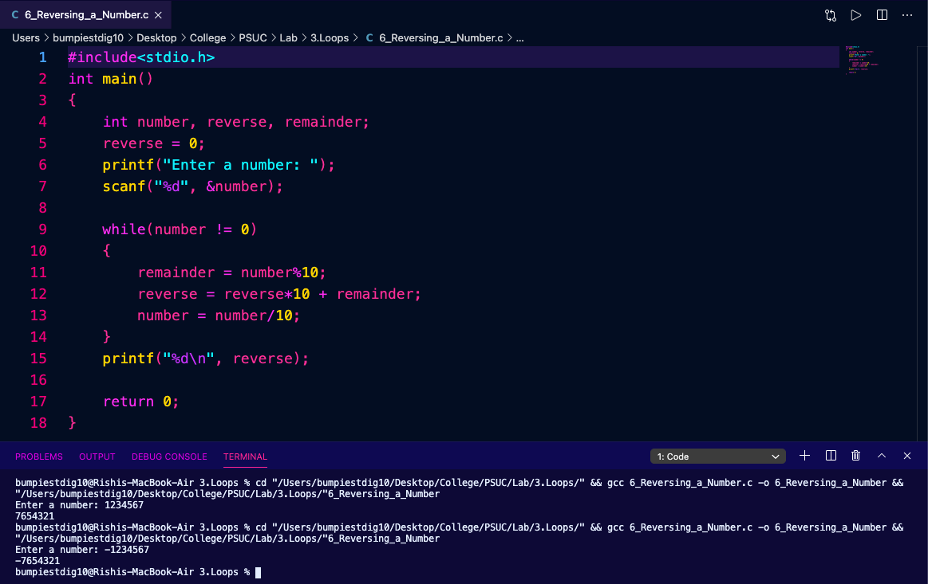

1. Check whether given number is Armstrong or not. An Armstrong number of three digits is an integer such that the sum of the cubes of its digits is equal to the number itself. For example, 371 is an Armstrong number since 33 + 73 + 13 = 371.

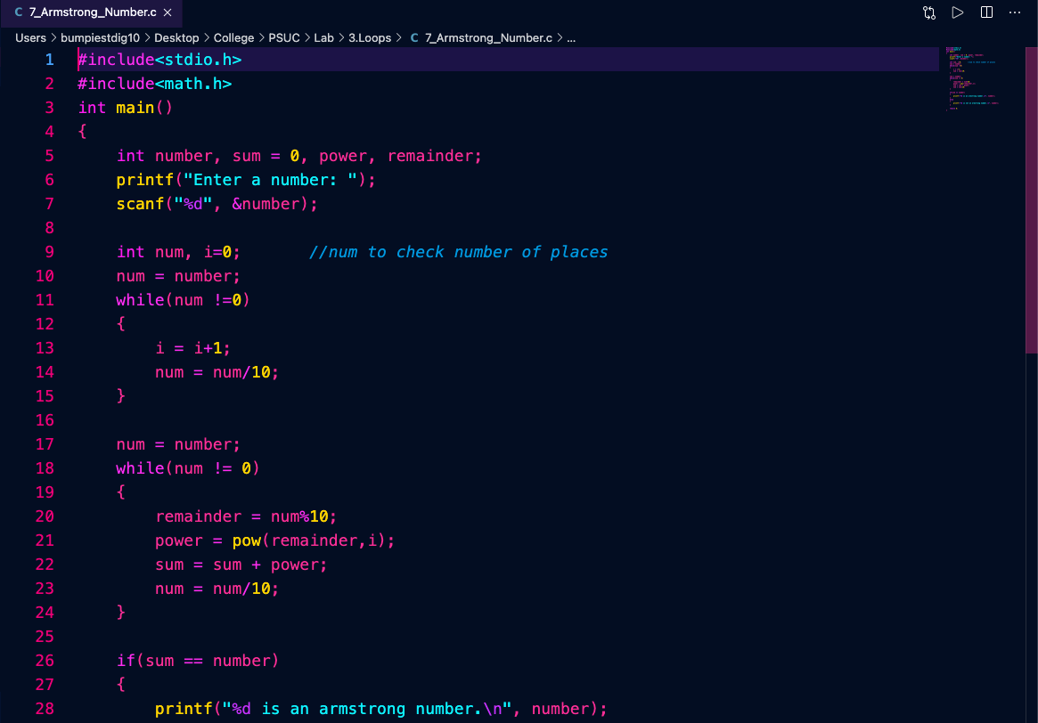

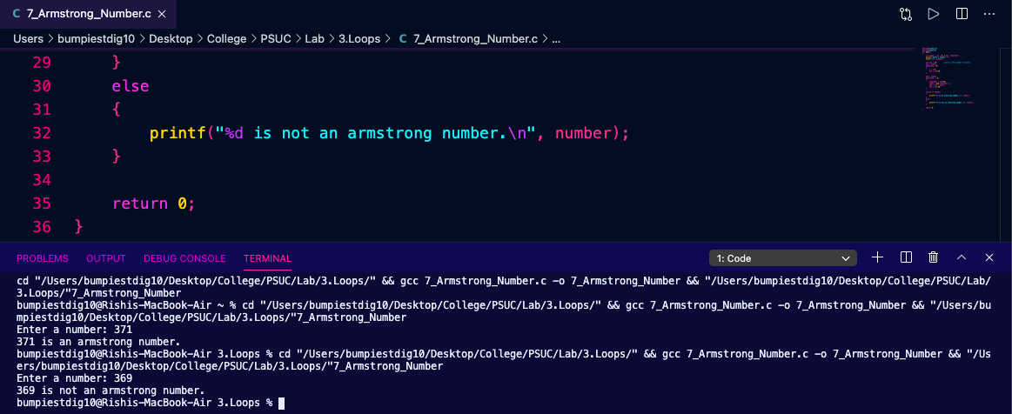

1. Print the Fibonacci numbers that fall in given range.

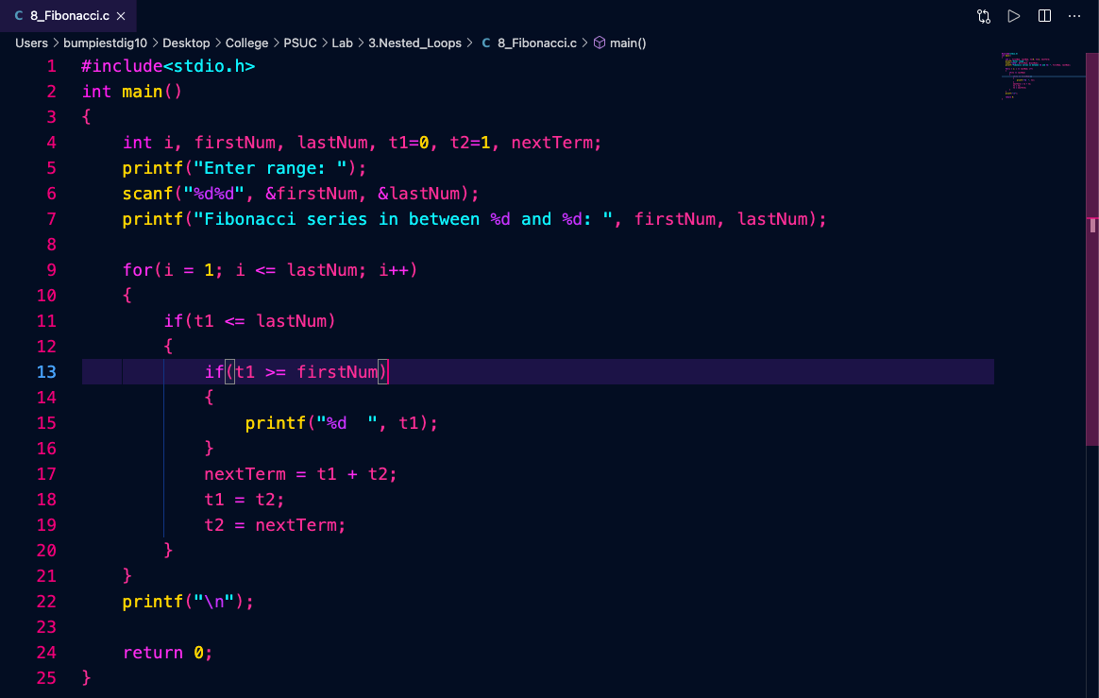

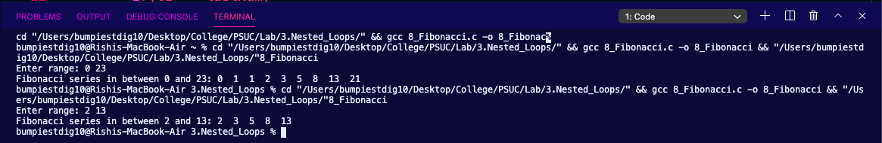

1. Print the prime numbers that fall in given range.

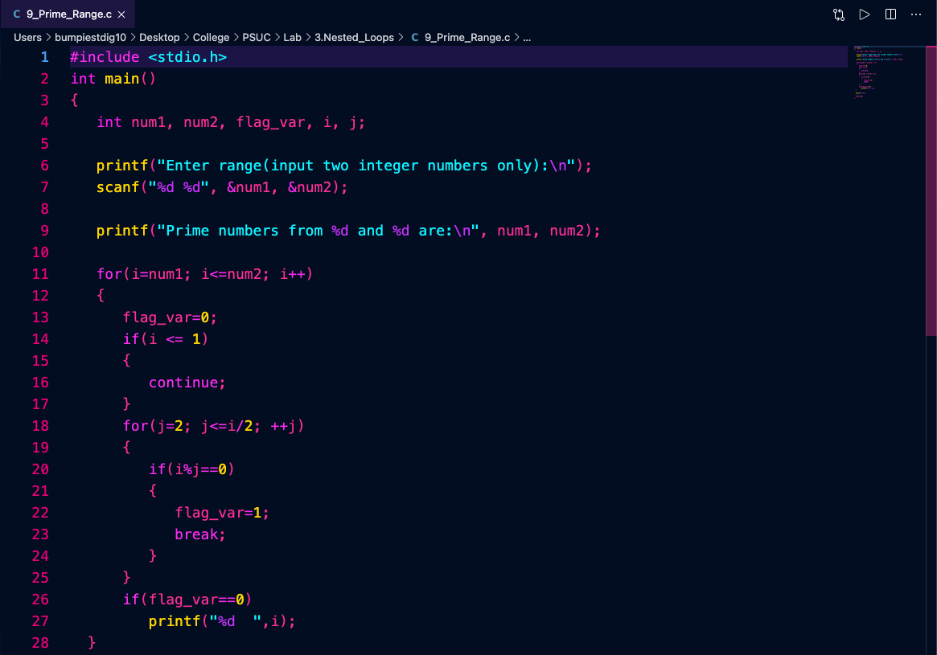

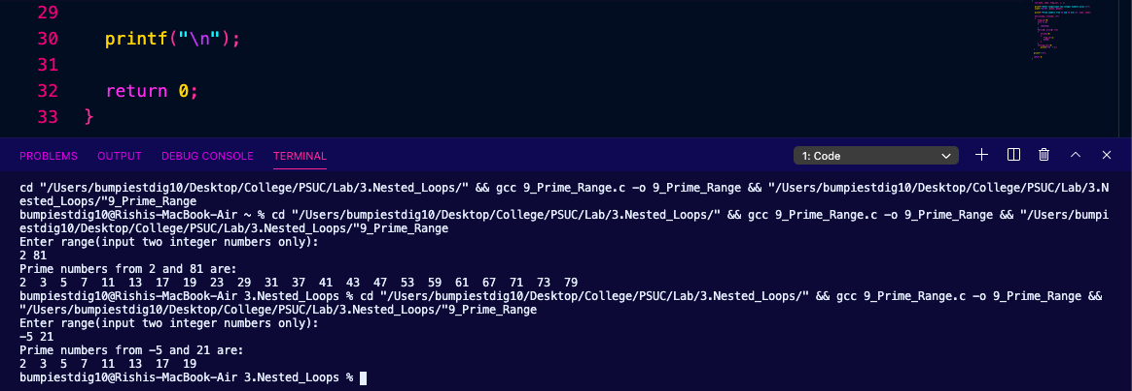

**Lab 4. 1-D and 2-D Array**

1. Find whether given number is available in an array or not (Linear Search).

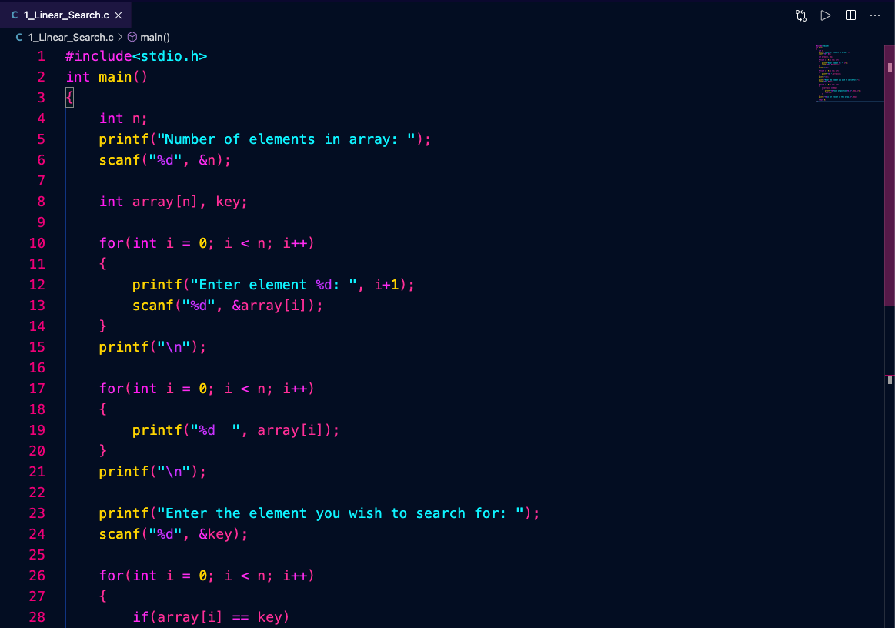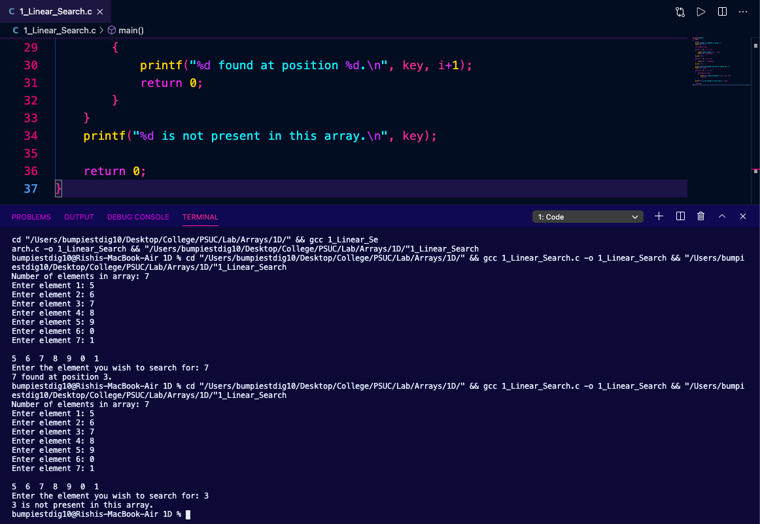

1. Find the largest and smallest element in an array

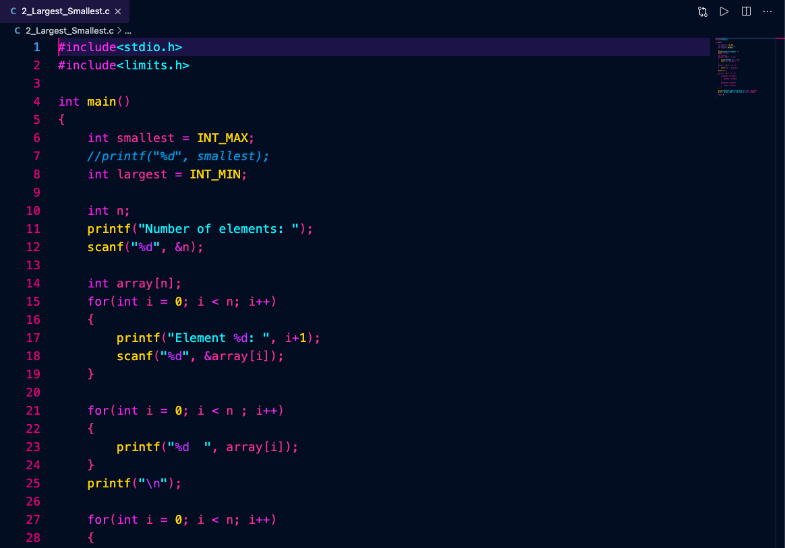

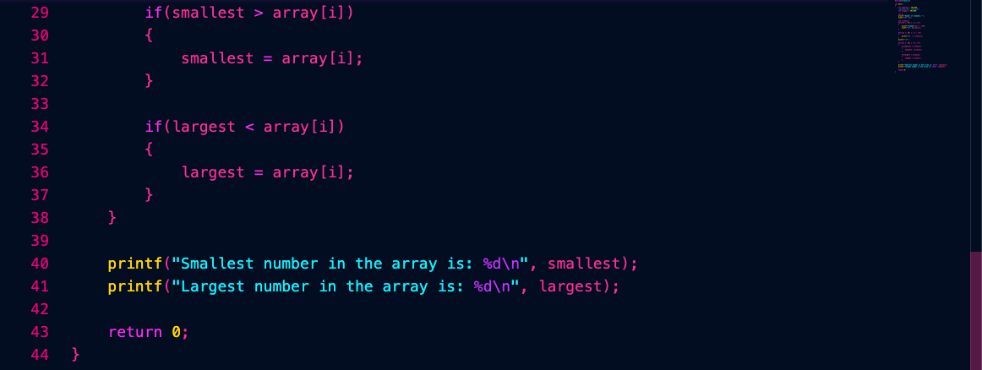

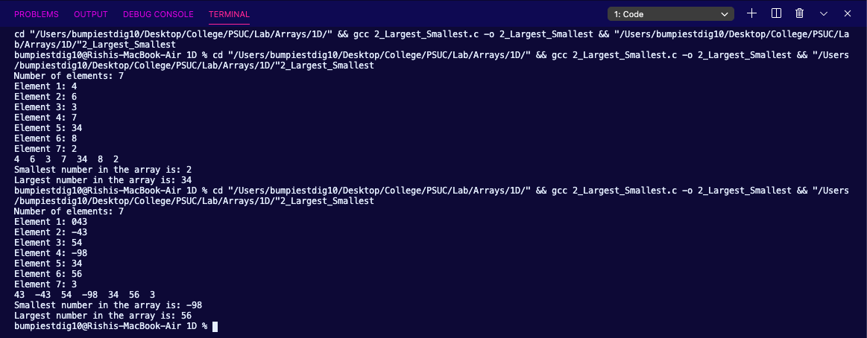

1. Find the number of positive numbers, negative numbers, odd numbers, even numbers and number of 0 of an array.

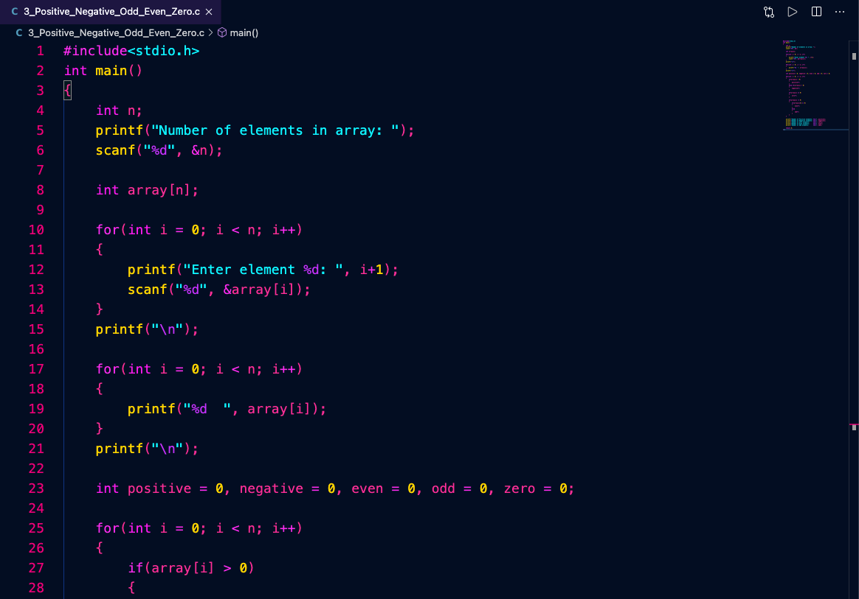

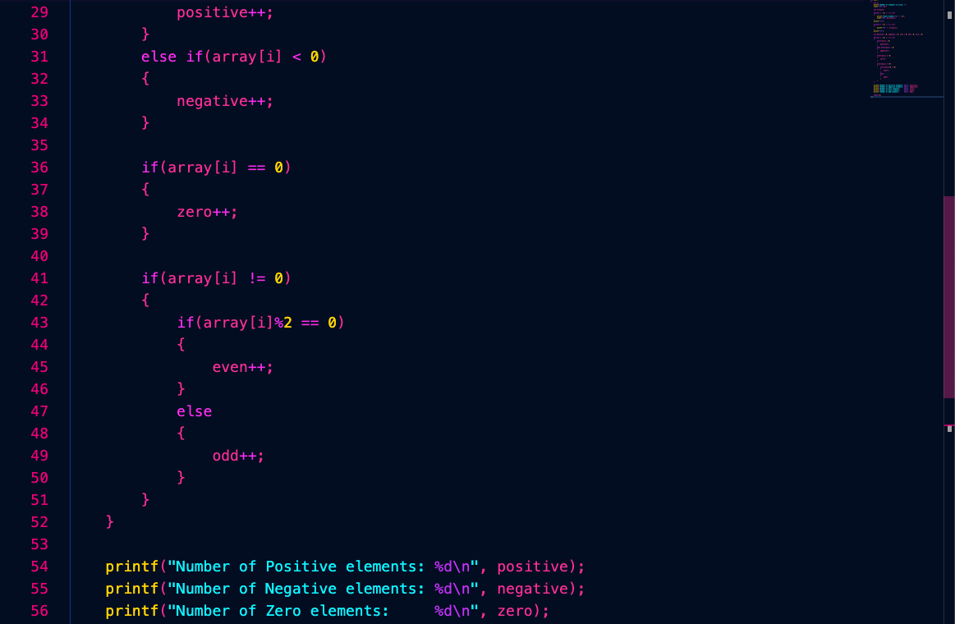

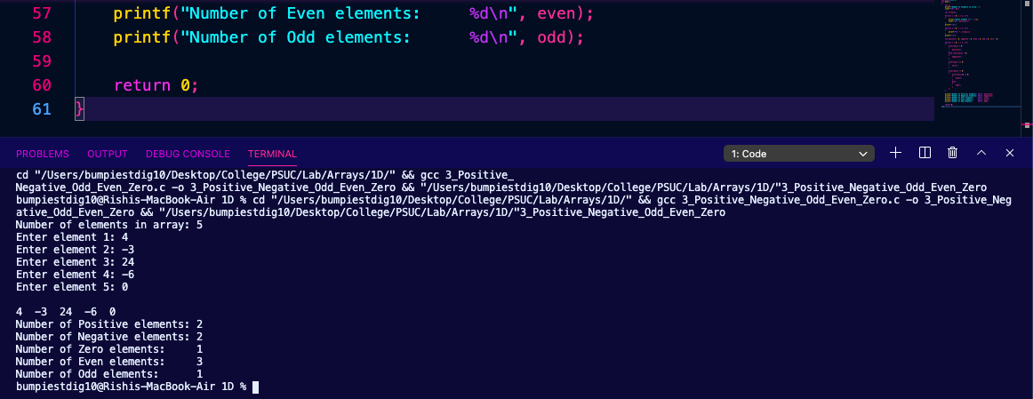

1. Reverse an array with an auxiliary array.

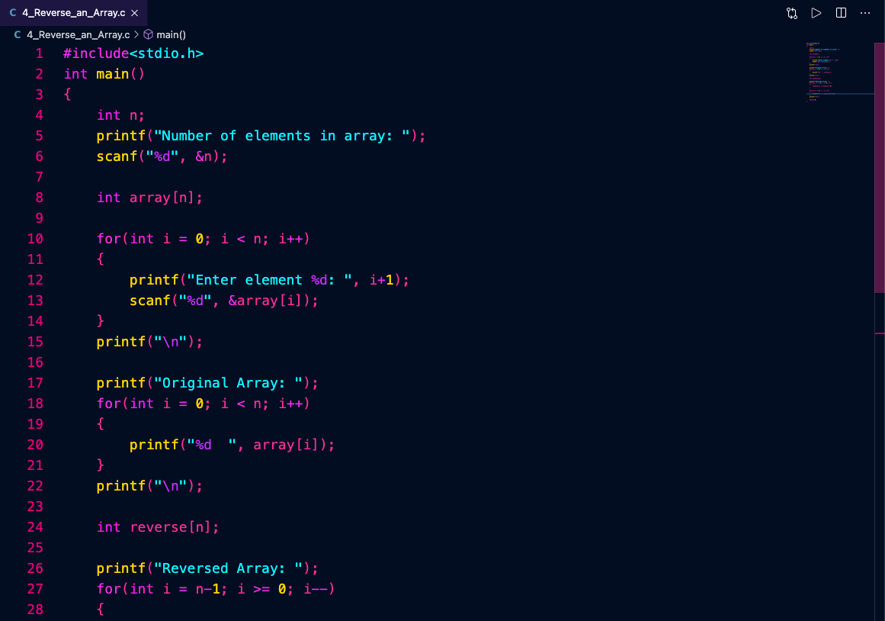

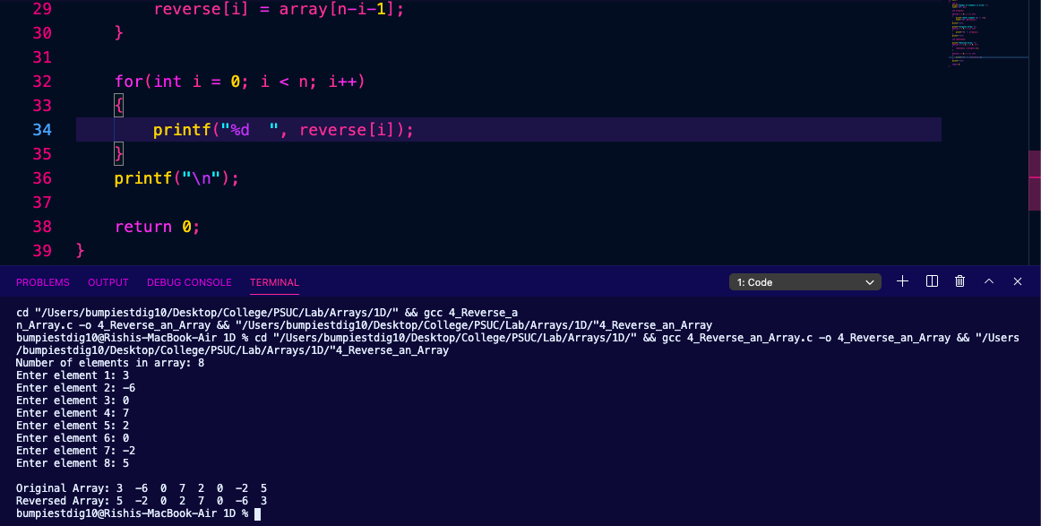



1. Arrange the elements of an array in ascending order by bubble sort method.

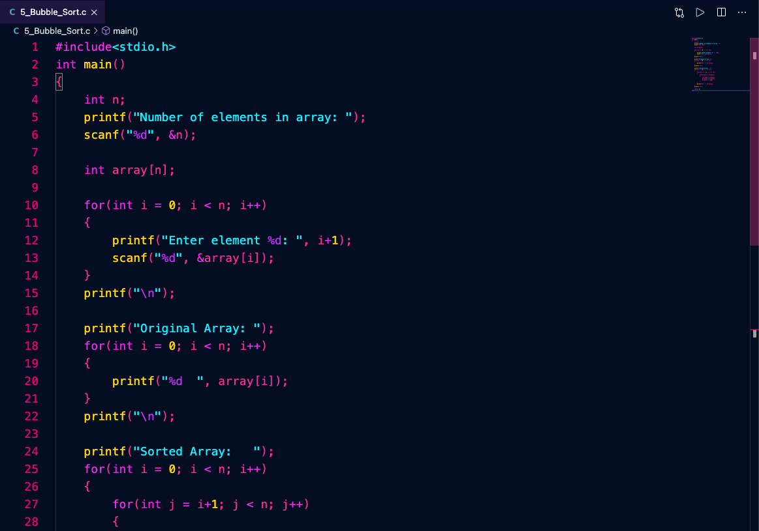

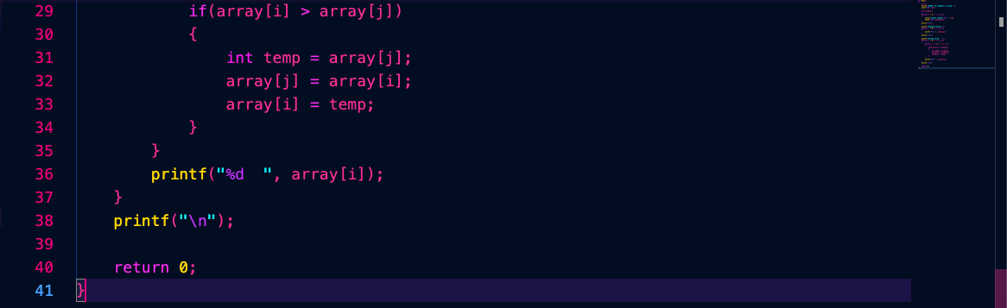

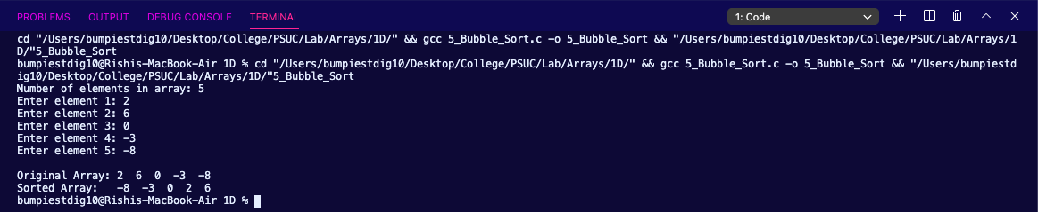

**Using 2-D Array**

1. Write a program to take 3 student marks of 5 subjects. Print the total marks of each student and average marks of each subject.

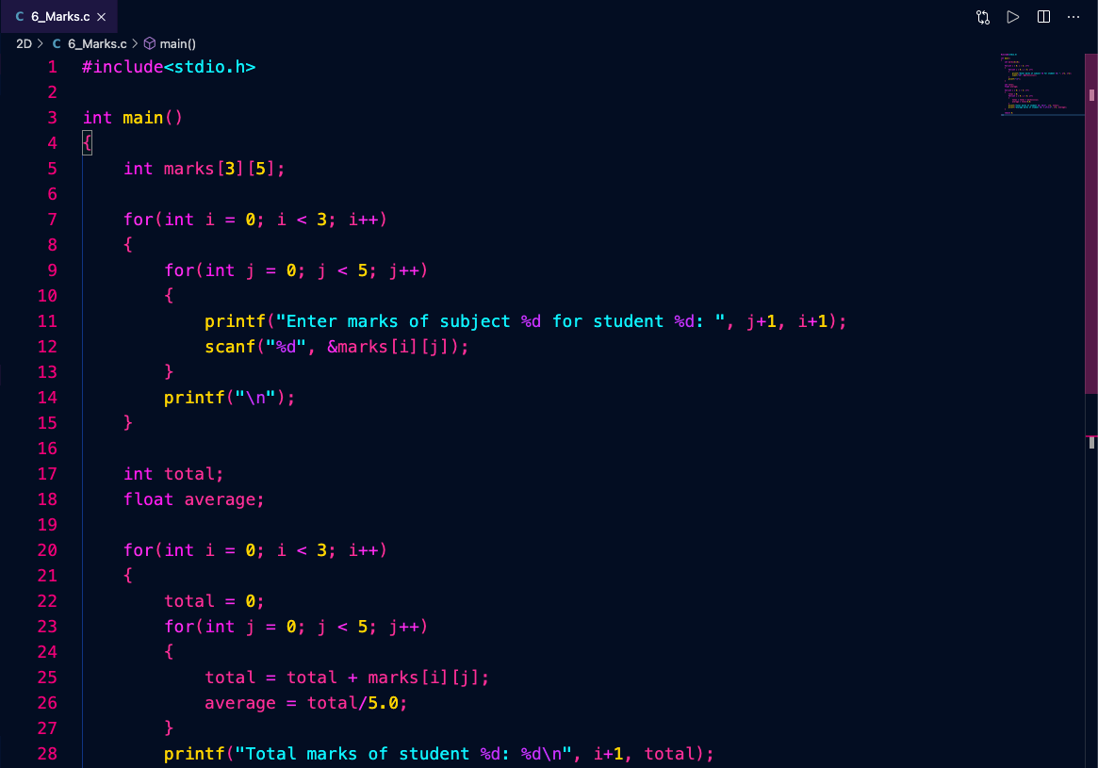

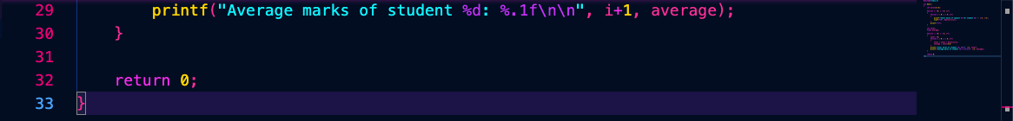

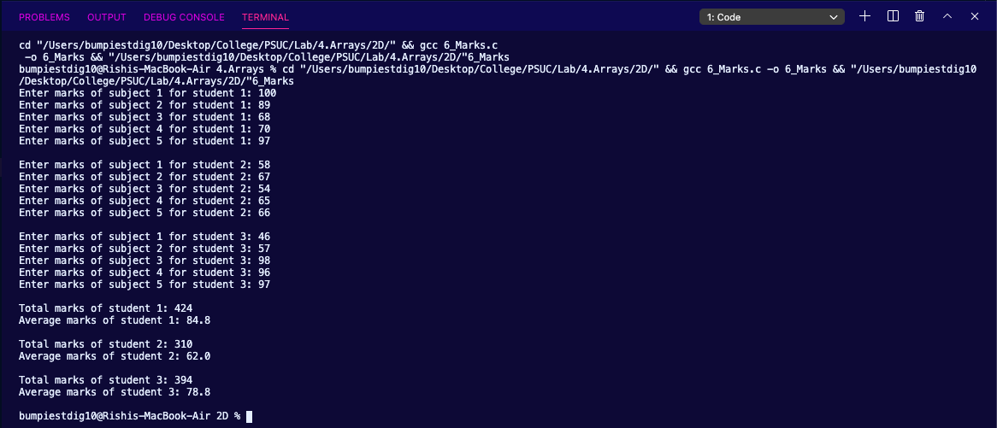

1. Multiplication of two matrices.

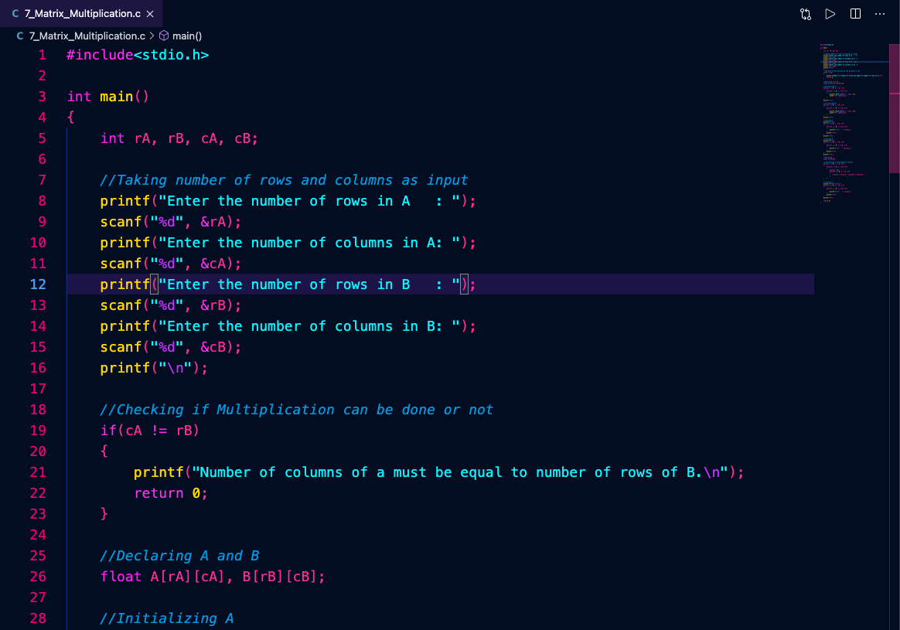

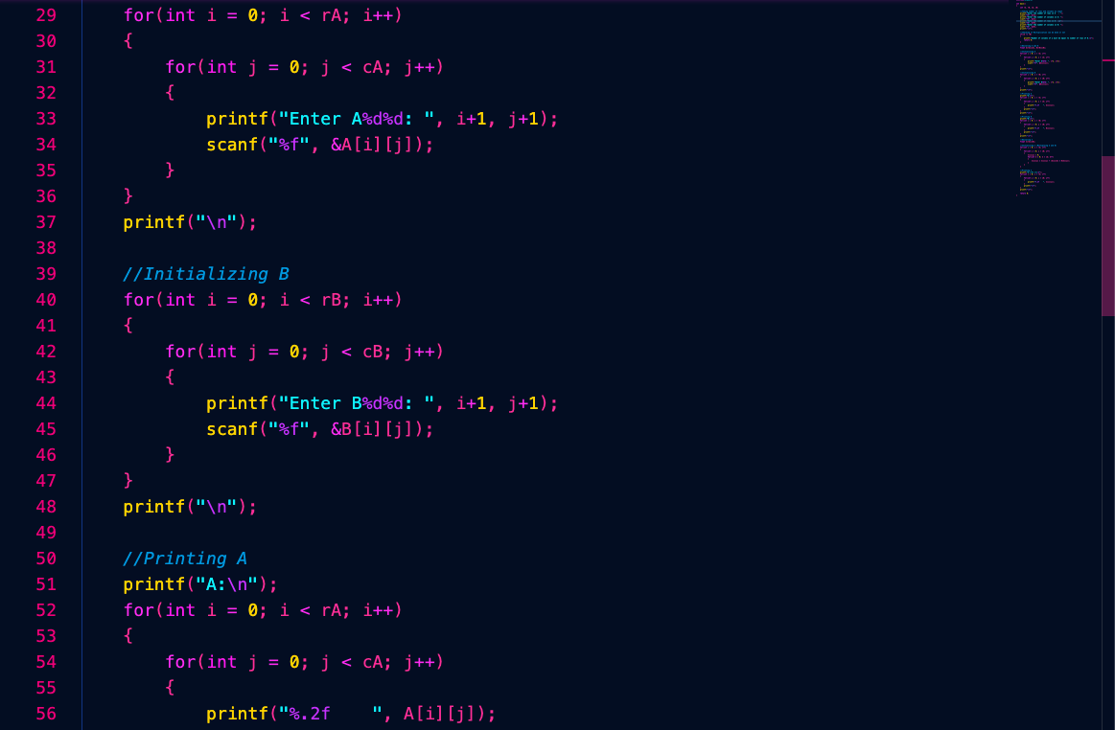

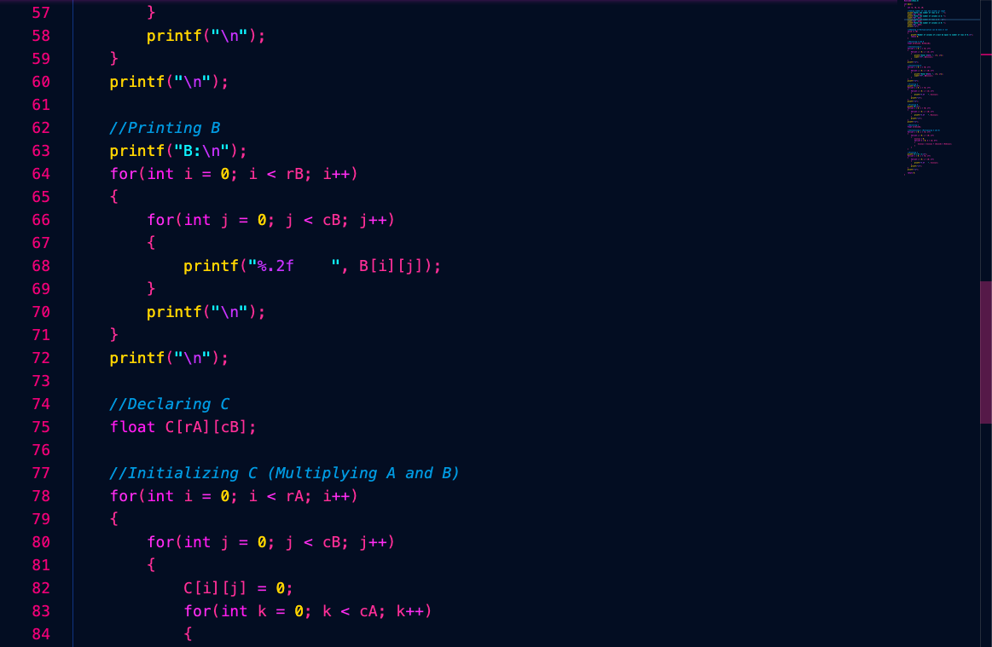

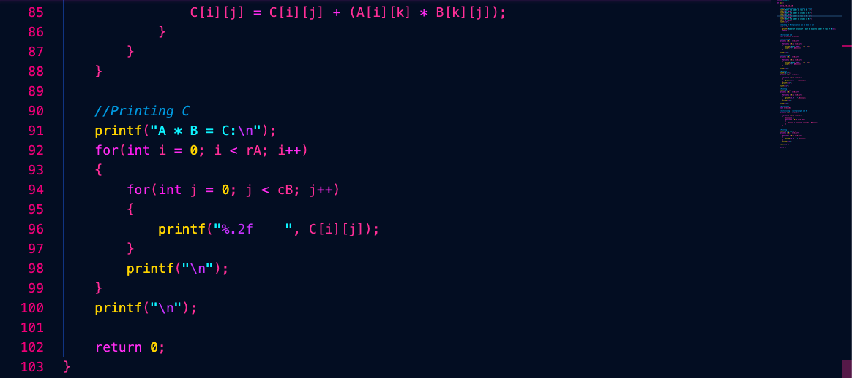

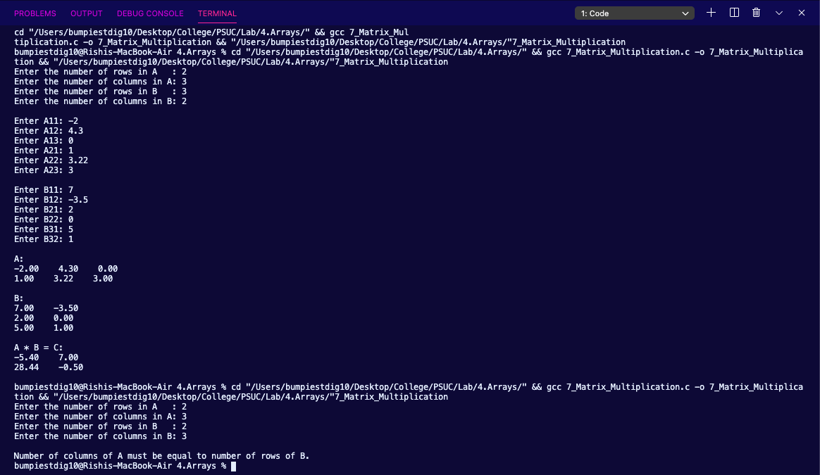

1. Find whether a given matrix is symmetric or not. (Hint: A = AT)

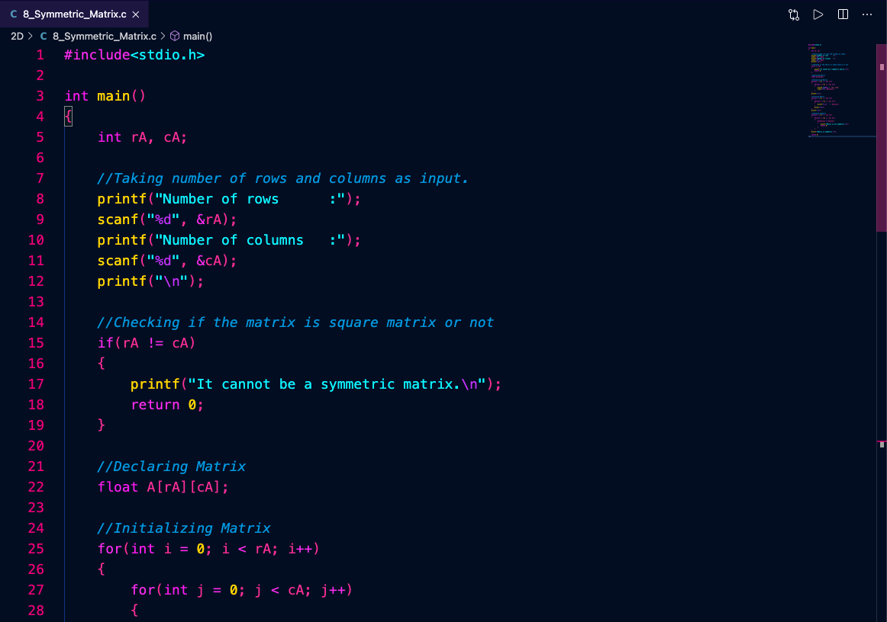

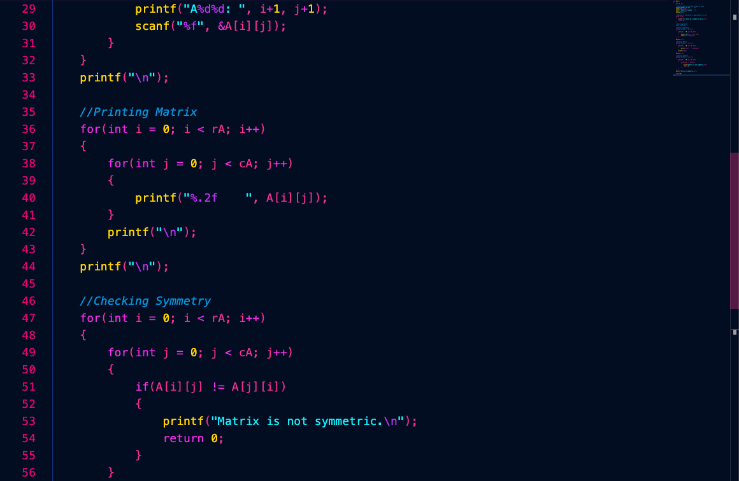

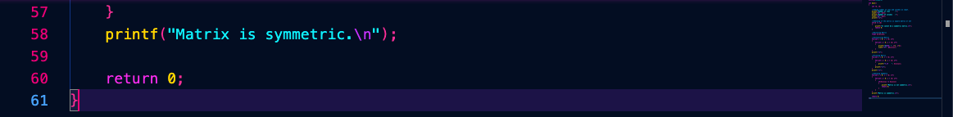

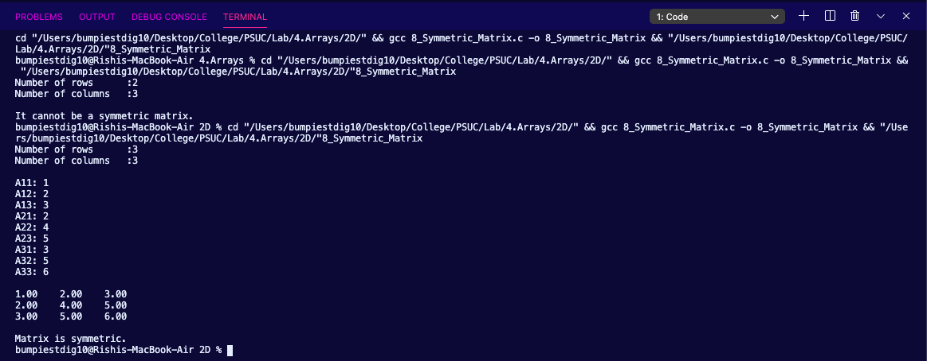

**Lab 5. Strings**

1. Print number of vowels and consonant in a string.

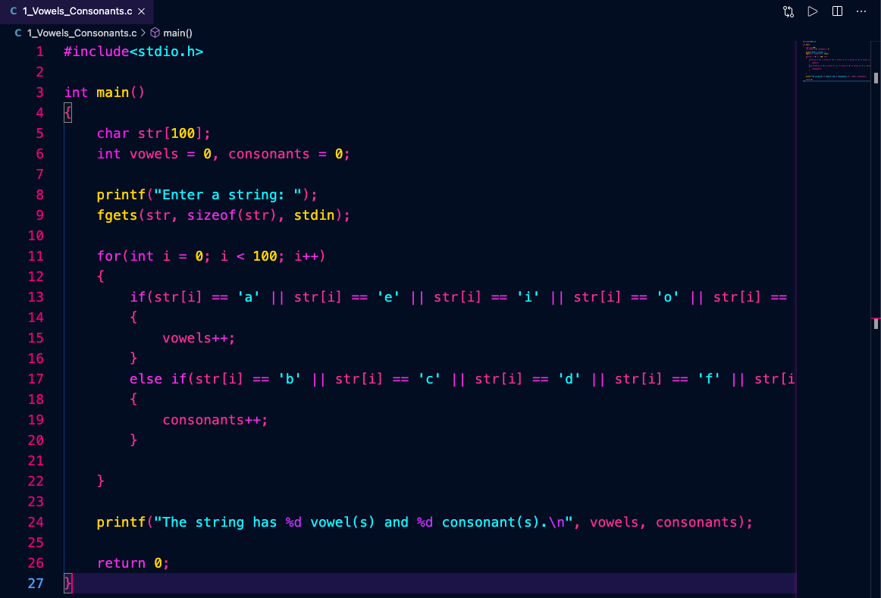

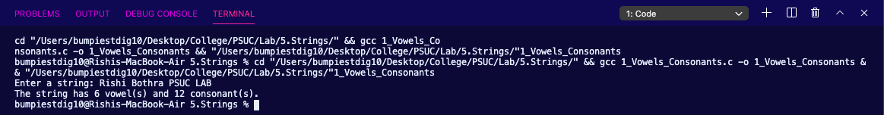

1. Change all lower-case letters into an upper-case in a sentence.

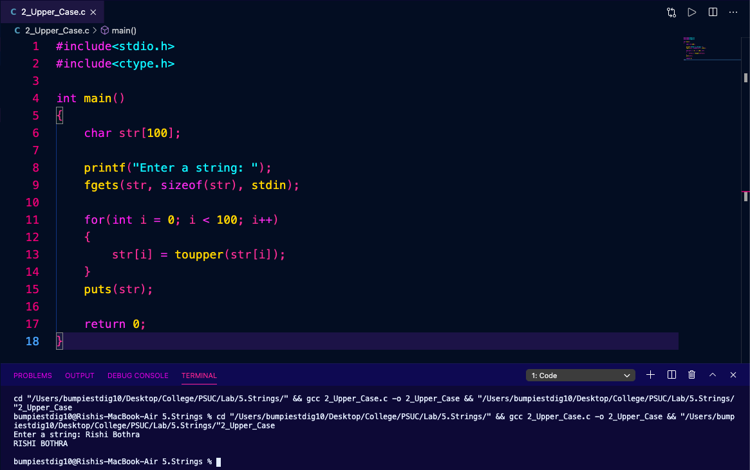

1. Count the number of words in a sentence.

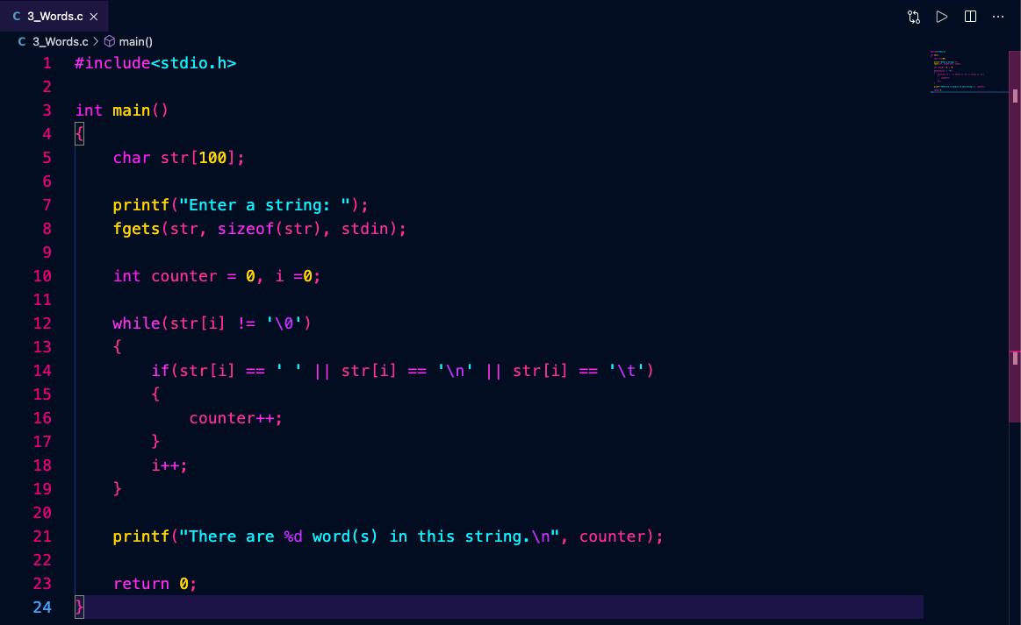

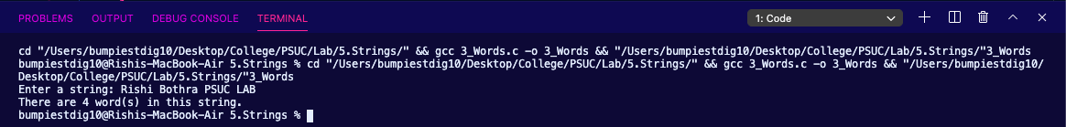

1. Reverse a string.

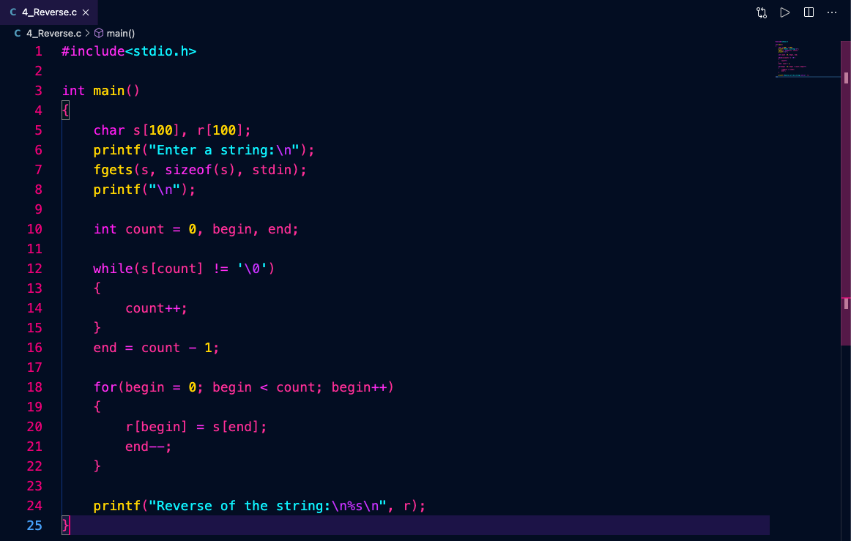

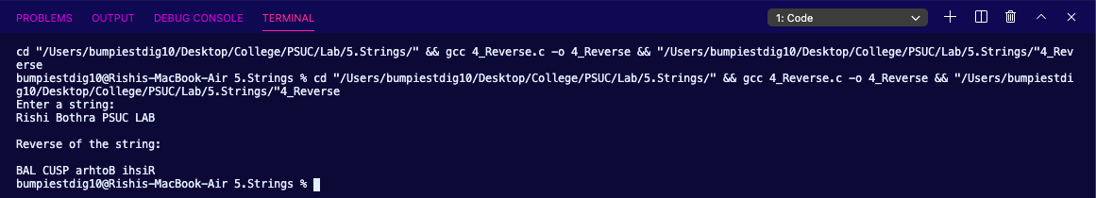

1. Find the string length of a string without using the predefined strlen() function.

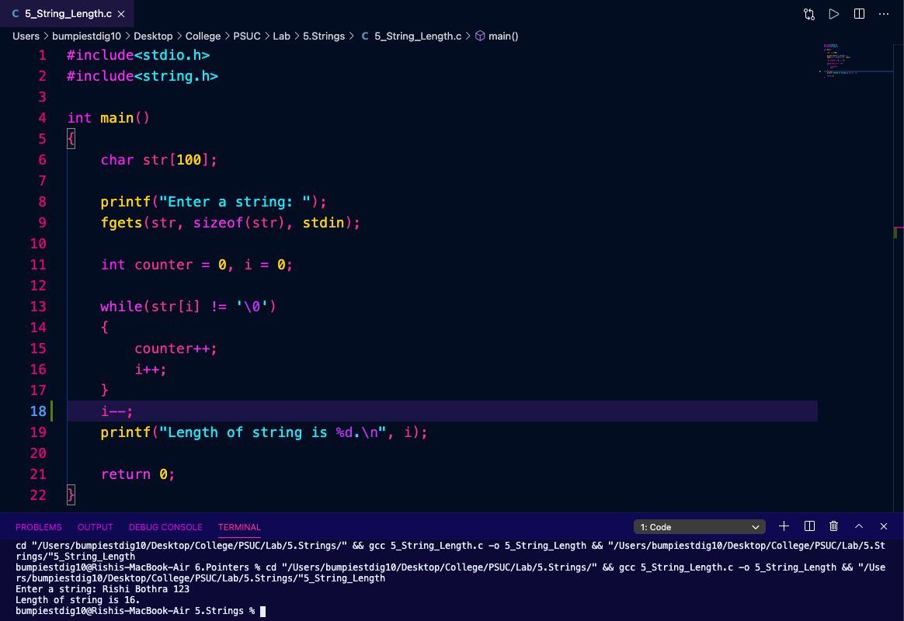

1. Find the sub-string of a given string.

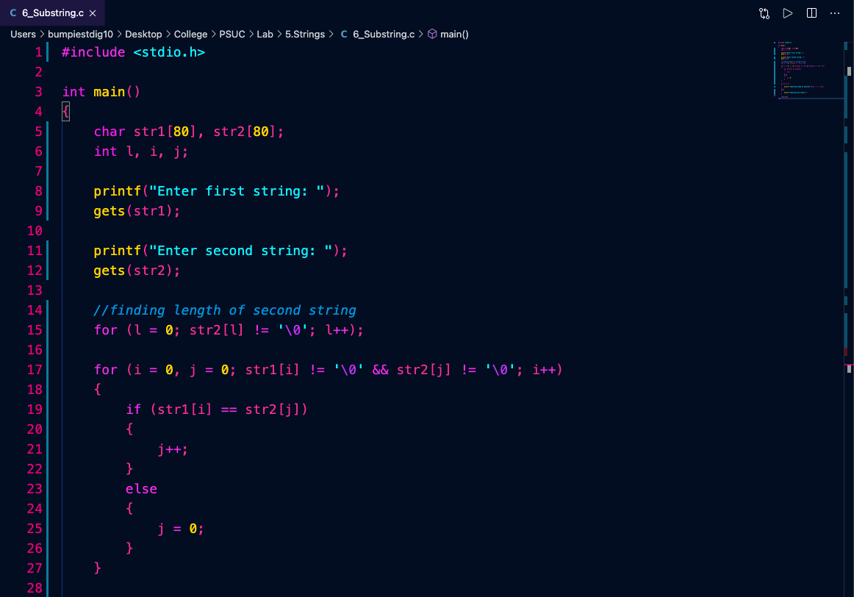

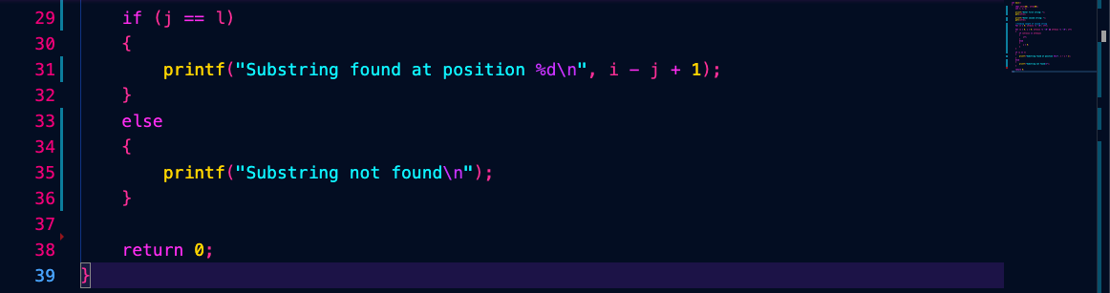

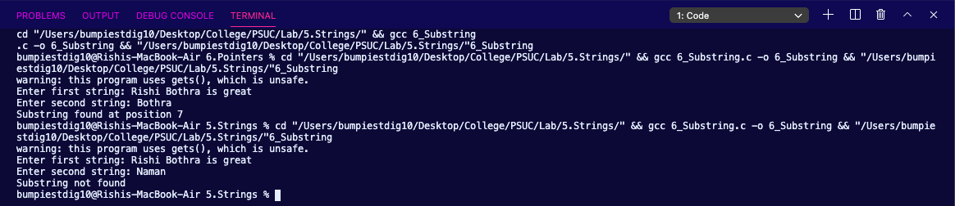

1. Check whether the given string is a palindrome or not.

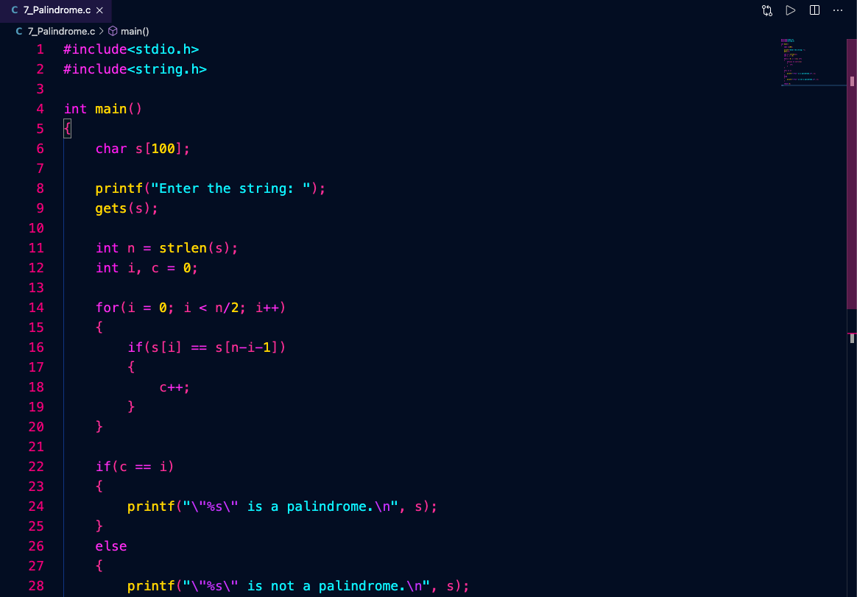

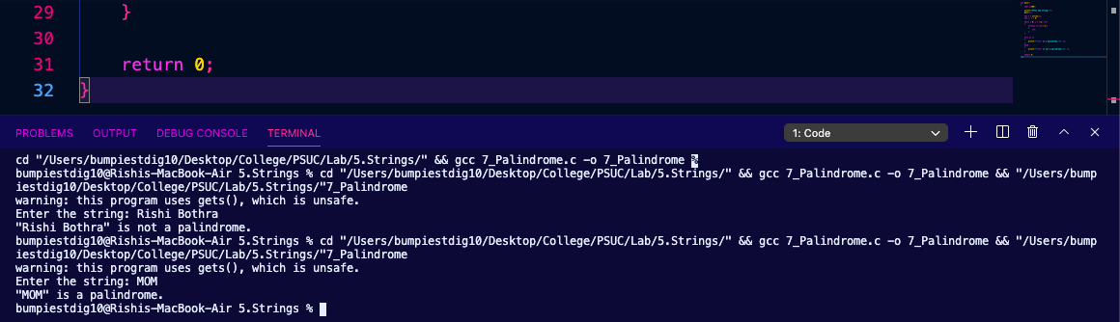

**Lab 6. Pointers**

1. Access two integers using pointers and add them.

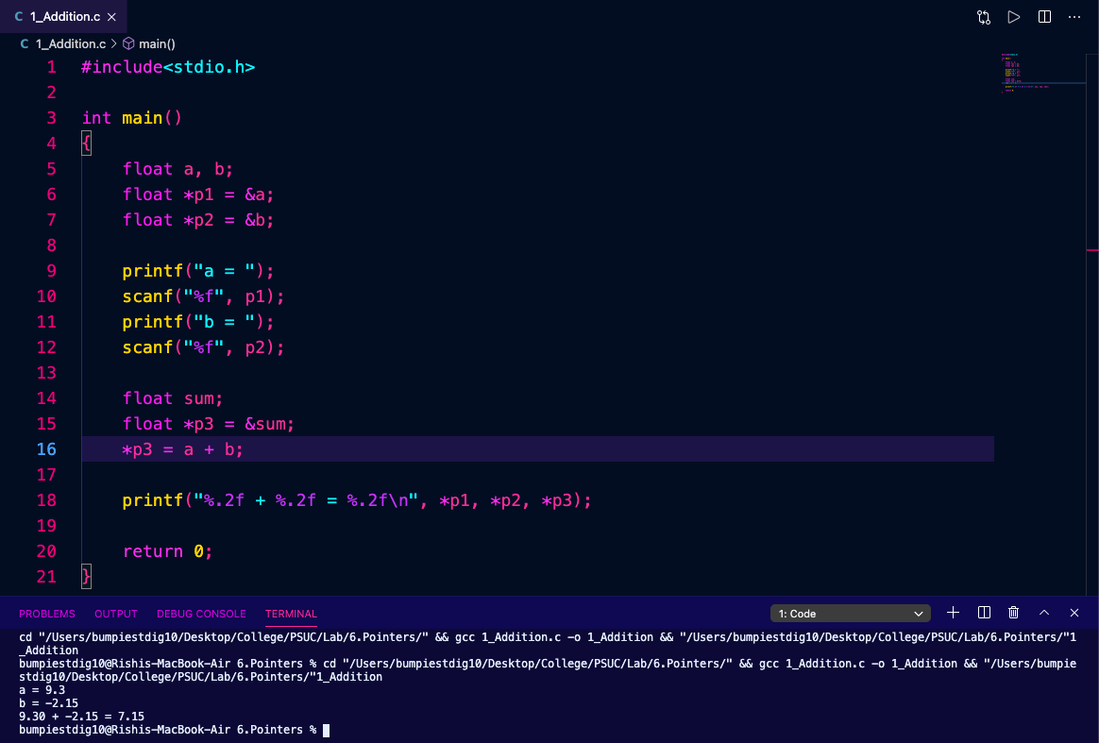

1. Write a program to find out the greatest and the smallest among the three numbers using pointers.

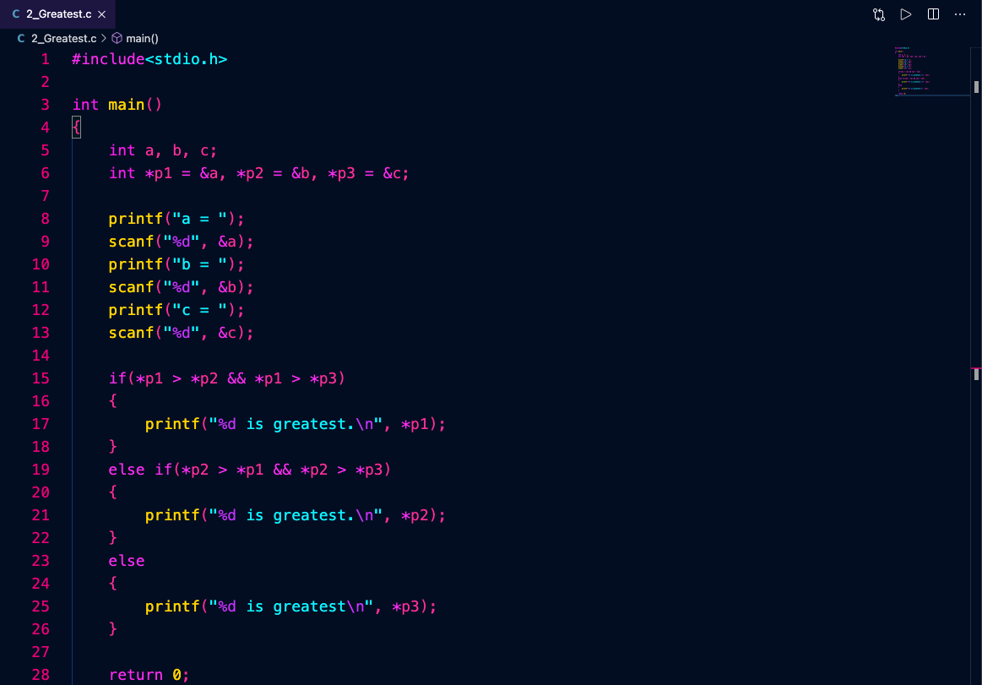

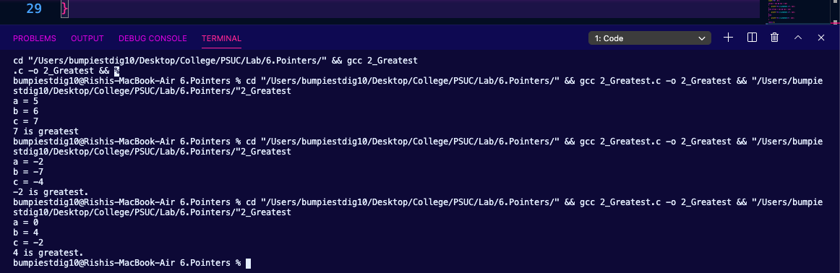

1. Determine the length of a character string using a pointer.

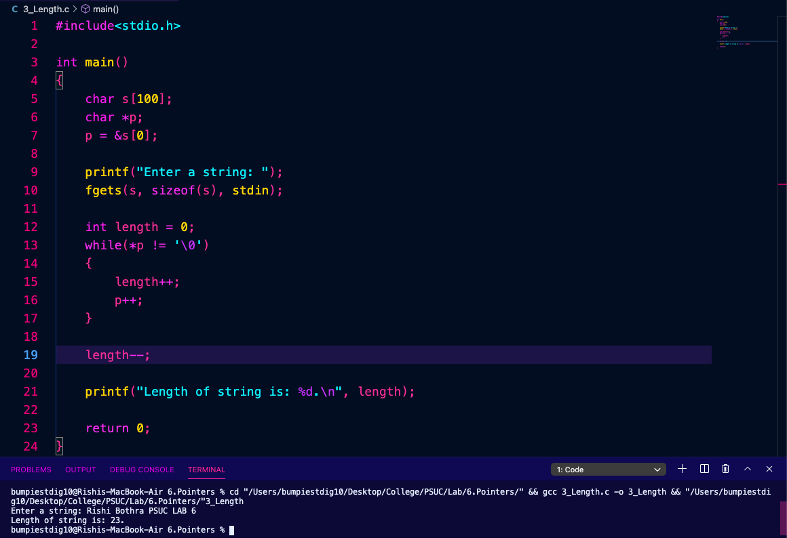

1. Determine the length of a character string using a pointer.

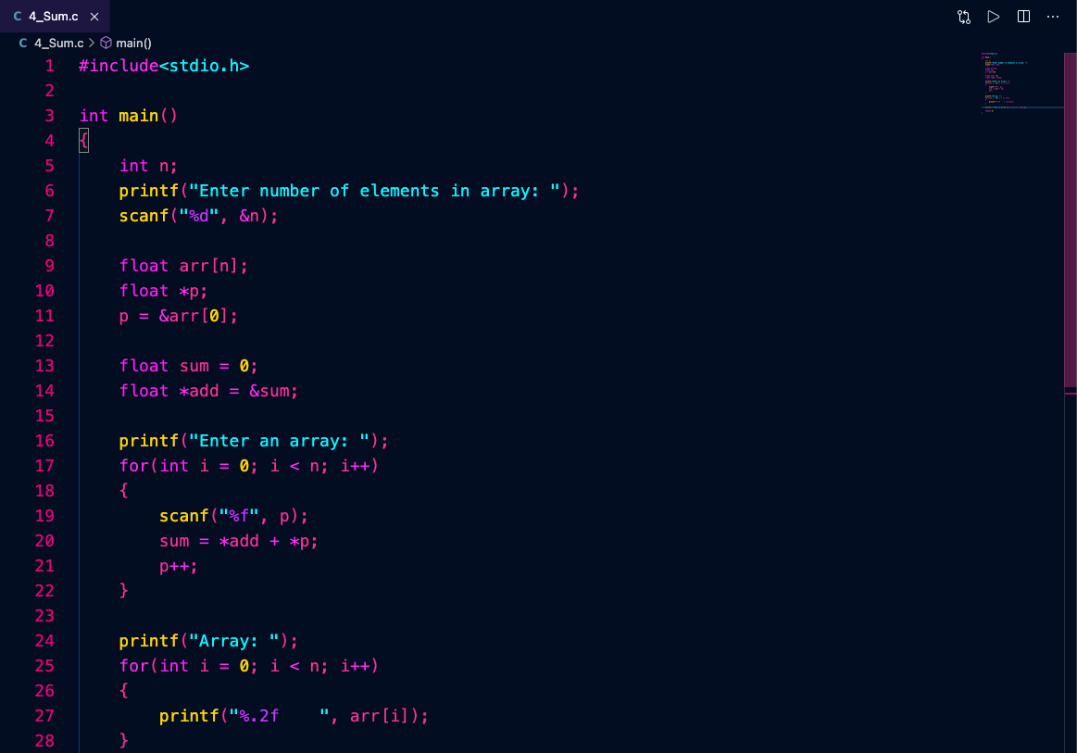

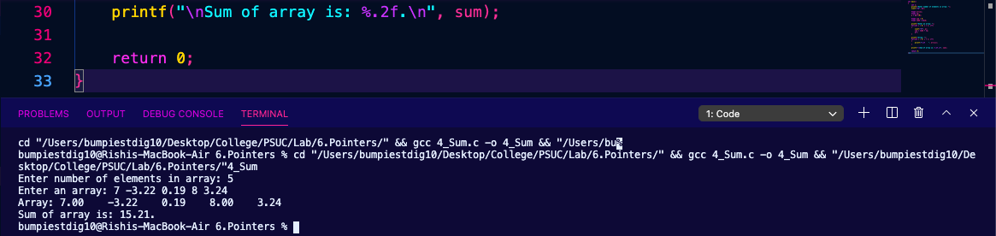

1. Determine whether a substring (string 1) is in the main sting or not. If present, return the pointer of the first occurrence.

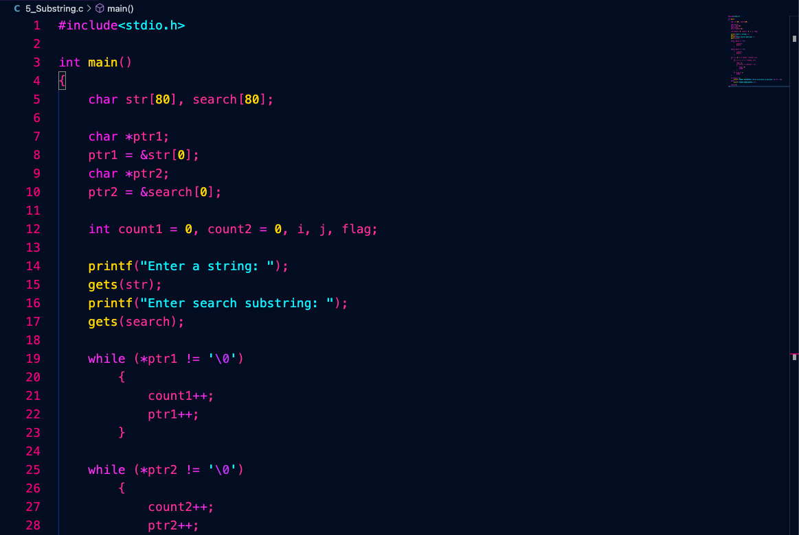

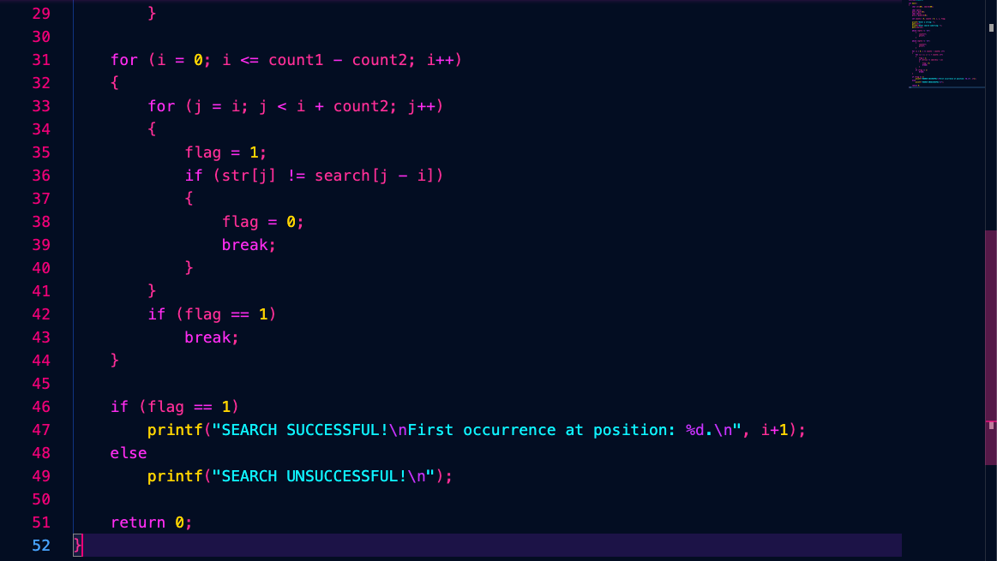

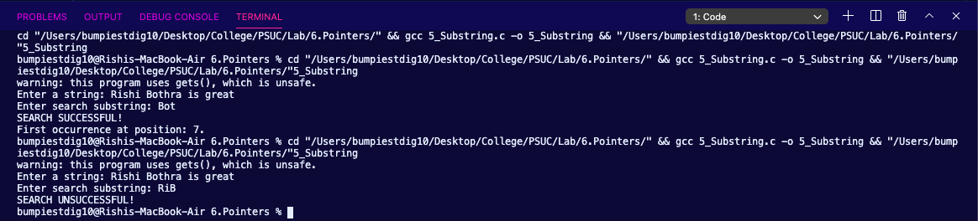

**Lab 7. Functions**

1. Find the factorial of a number using a function.

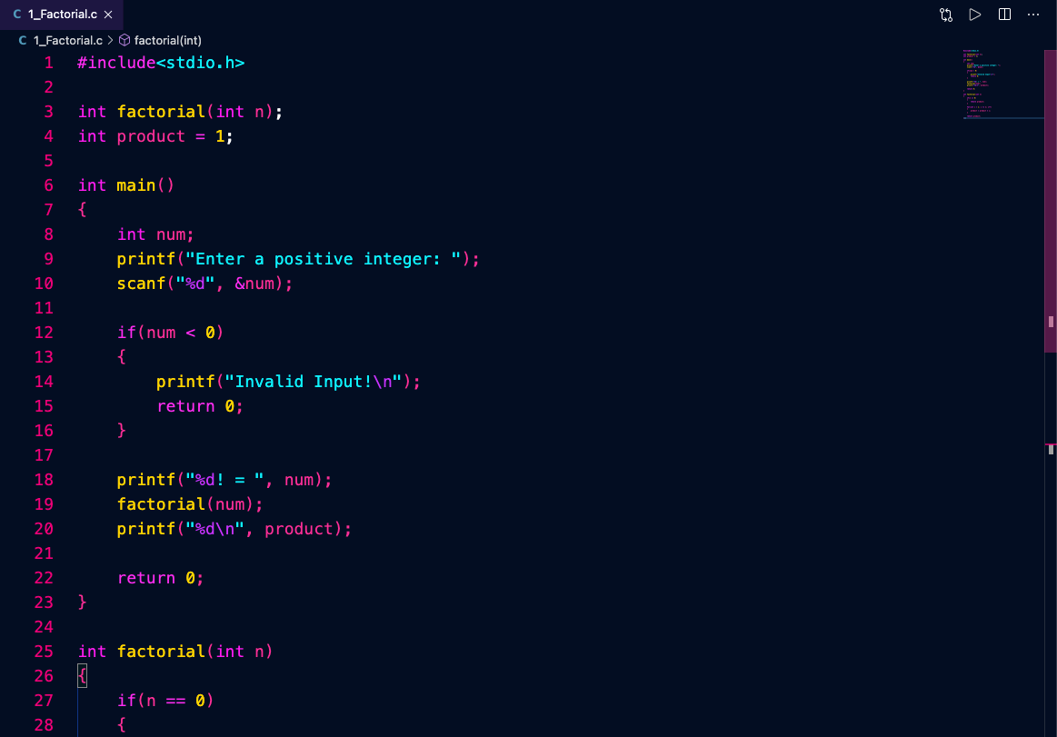

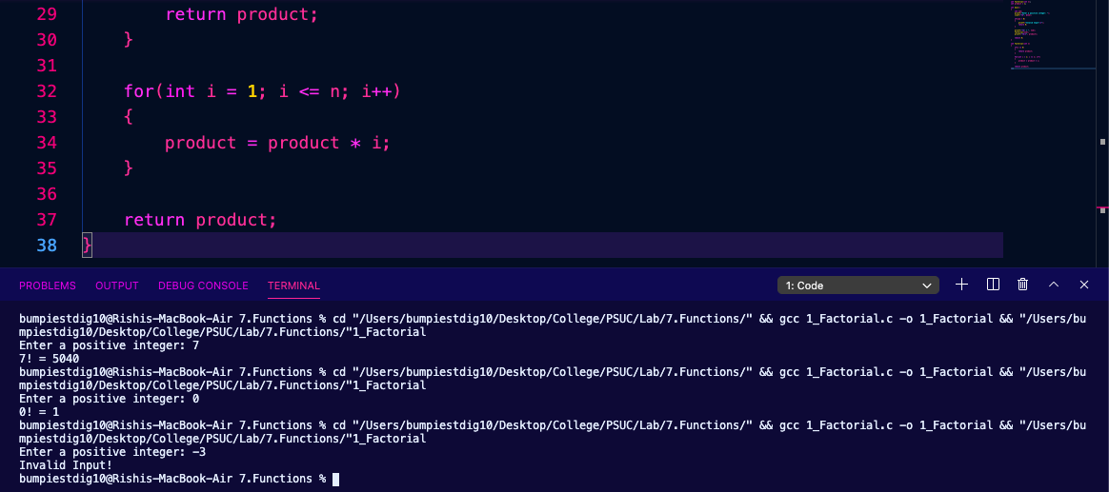

1. Find the maximum of a given set of numbers using functions.

Find GCD of two numbers recursively.

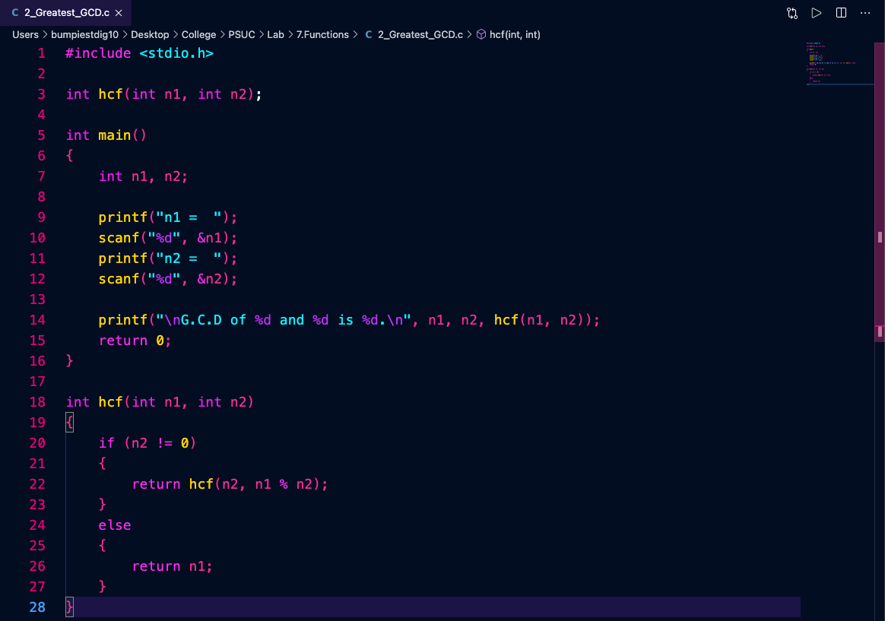

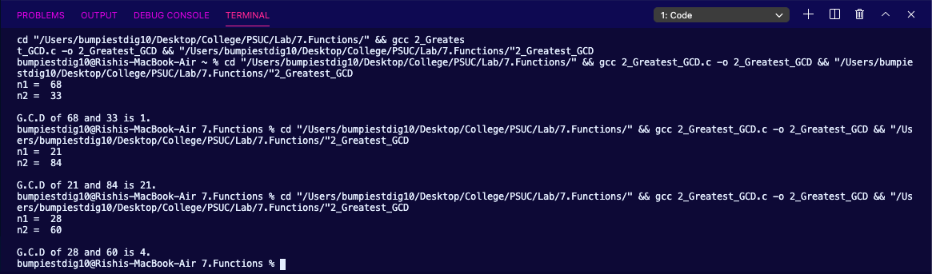

1. Check whether the given number is prime or not. Using this function generate first n prime numbers using the above function.

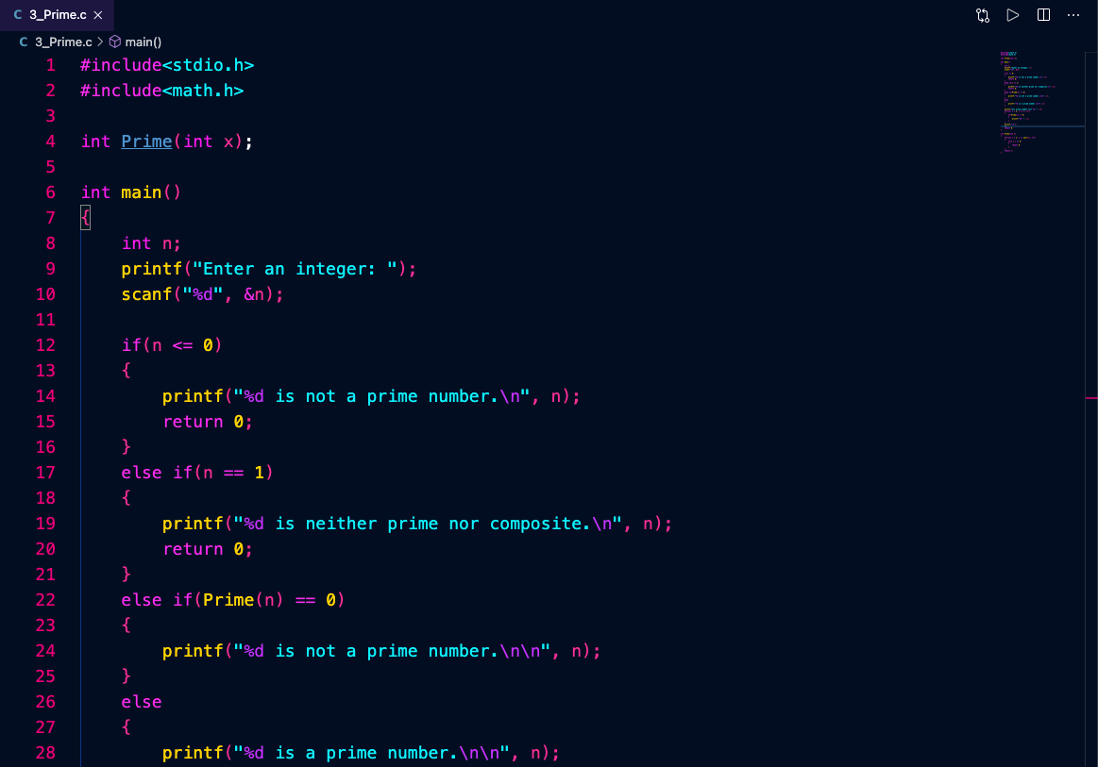

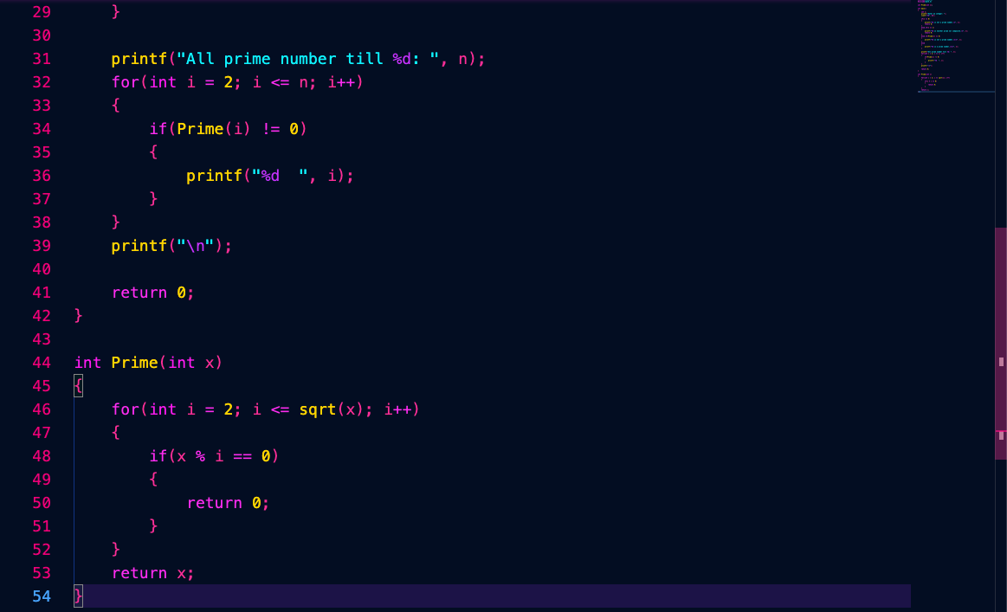

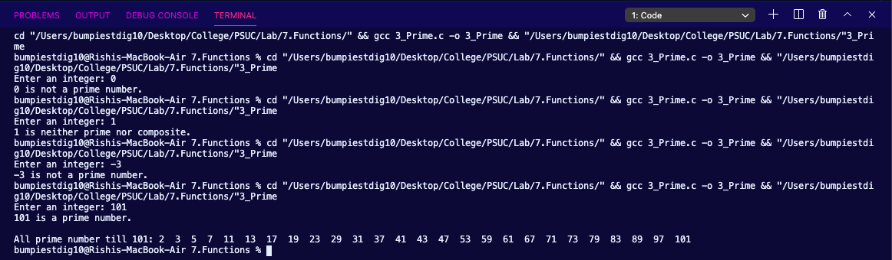

1. Write a function to generate the nth Fibonacci term using recursion. Print first N Fibonacci terms using this function.

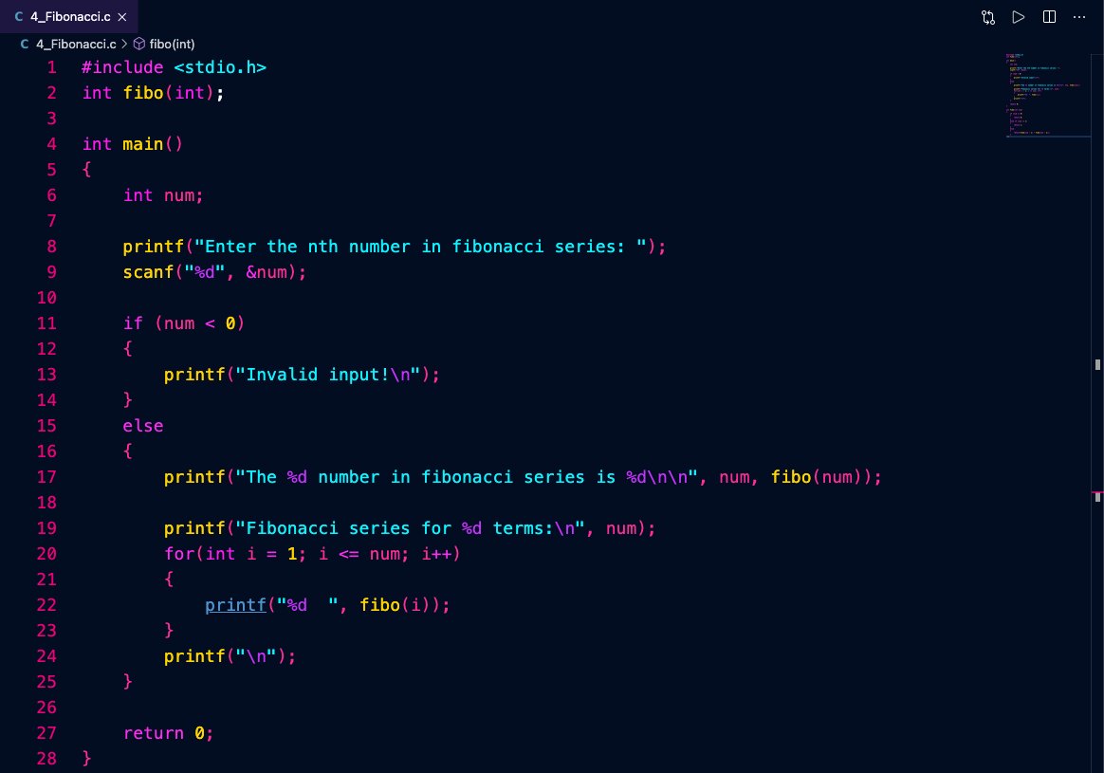

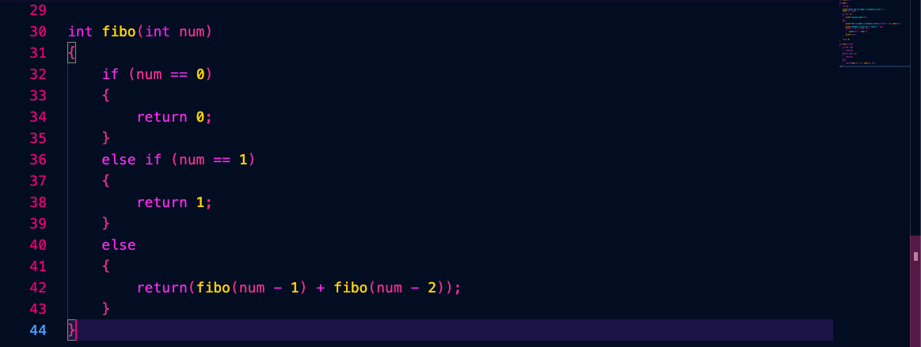

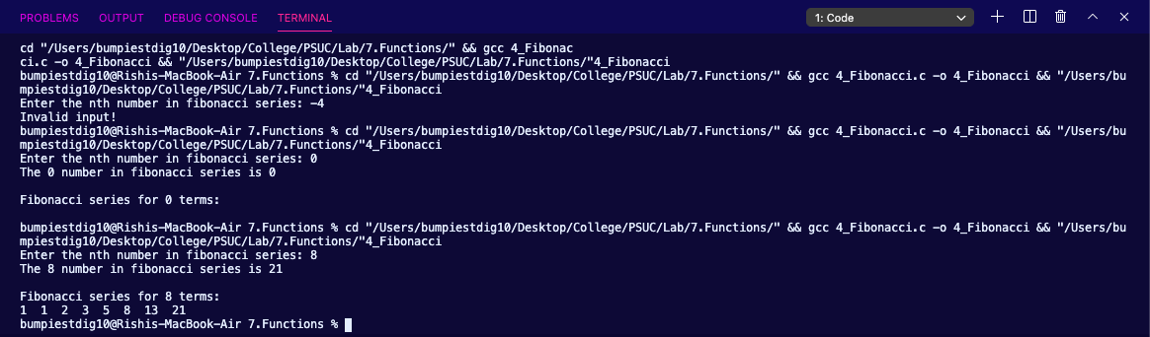

1. Check if the given string is a palindrome or not, using string handling function.

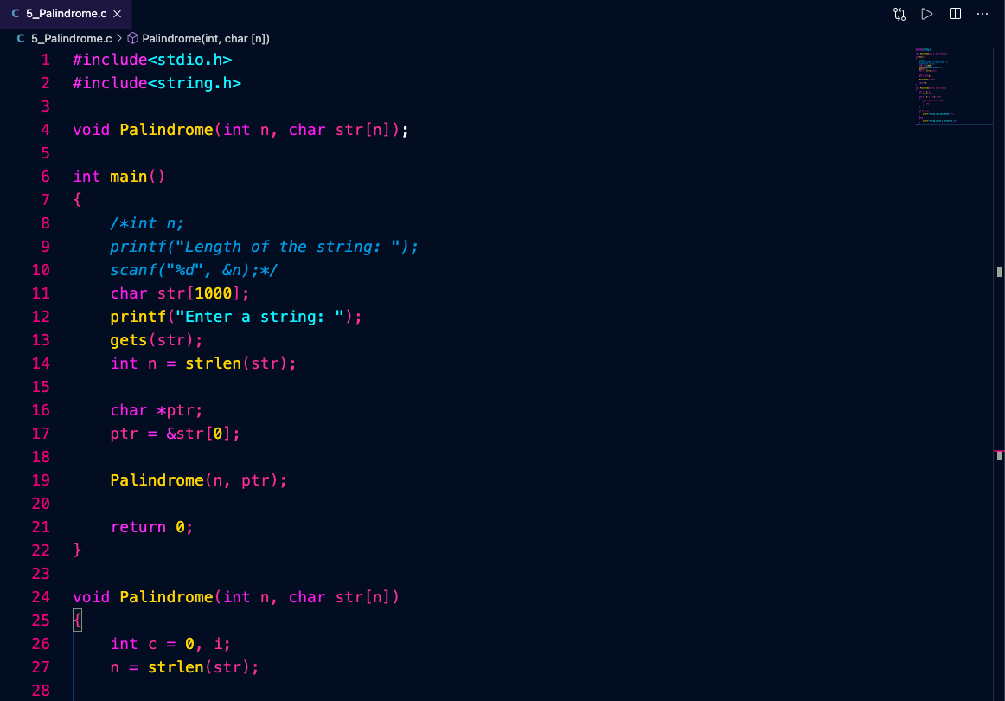

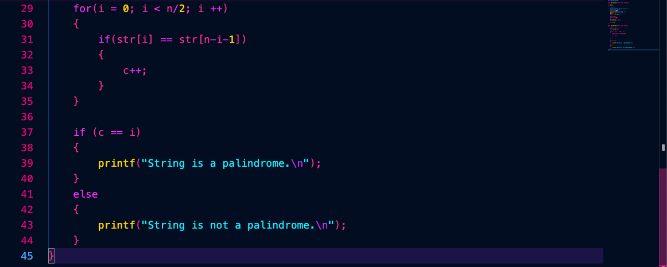

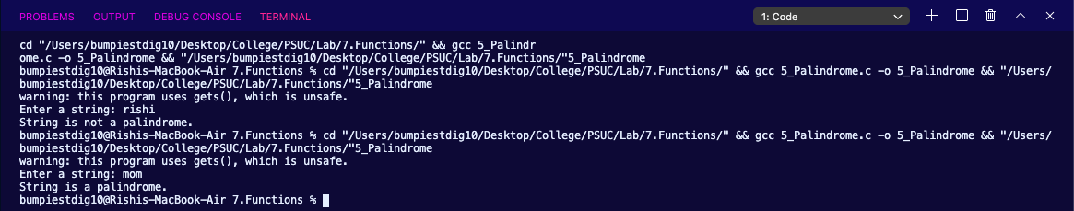

1. Write a function **Sort** for sorting a list of names which will use a function **compare** to compare two names. (bubble Sort may be used).